ChainGuard: Digital Supply Chain Compliance Tracker

A Smart Compliance Monitoring System for Medicine Delivery in Bangladesh

**1. Introduction 1**

1.1 Objectives 1

1.2 Key Features & Operations 2

1.2.1 For Logistics Manager 2

1.2.2 For Transport Vendor 2

1.2.3 For System Admin 2

1.3 ChainGuard Differentiators 2

**2. Scenario Writing 3**

2.1 FR01: Registration 3

2.2 FR02: Login 3

2.3 FR03: Schedule Shipments and Assign Routes 3

2.4 FR04: Upload Documents 4

2.5 FR05: Real-Time Shipment Tracking 4

2.6 FR06: Cold Chain Monitoring 4

2.7 FR07: Pickup & Drop-off Logging 5

2.8 FR08: Proof of Delivery Submission 5

2.9 FR09: Compliance Dashboard & Alerts 5

2.10 FR10: User & Role Management 6

2.11 FR11: Compliance Rule Configuration 6

2.12 FR12: System Monitoring & Maintenance 6

**3. Stakeholder 7**

**4. User Profile 8**

4.1 User Profile-01: Logistics Manager 8

4.2 User Profile-02: Transport Vendor 9

4.3 User Profile-03: System Admin 10

**5. Scope 11**

5.1 User Registration and Login 11

5.2 Shipment Scheduling and Route Assignment 11

5.3 Compliance Management 11

5.4 Real-Time Tracking and Monitoring 11

5.5 Delivery Event Logging 11

5.6 Dashboards and Notifications 11

5.7 User and Role Management 11

5.8 Security and Maintenance 11

**6. Feasibility Study 12**

6.1 Technical Feasibility 12

6.2 Operational Feasibility 12

6.3 Economic Feasibility 12

6.4 Scheduling Feasibility 12

6.5 Security & Privacy Considerations 12

**7. Project Block Diagram 15**

7.1 Logistic Manager 15

7.2 Transport Vendor 16

7.3 System Admin 17

**8. Software Requirement Specification 18**

8.1 SRS 18

8.2 Use Case Diagram 20

8.3 Use Case Descriptions 21

8.3.1 Registration 21

8.3.2 Login 22

8.3.3 Schedule Shipments and Assign Routes 23

8.3.4 Upload Documents 24

8.3.5 Real-Time Shipment Tracking 25

8.3.6 Cold Chain Monitoring 26

8.3.7 Pickup & Drop-off Logging 27

8.3.8 Proof of Delivery Submission 28

8.3.9 Compliance Dashboard & Alerts 29

8.3.10 User & Role Management 30

8.3.11 Compliance Rule Configuration 31

8.3.12 System Monitoring & Maintenance 32

**9. System Design 33**

9.1 Data Flow Diagram 33

9.1.1 Data Flow Diagram Level-0 33

9.1.2 Data Flow Diagram Level-1 34

9.1.3 Data Flow Diagram Level-2 35

9.2 Activity Diagram 36

9.2.1 Registration 36

9.2.2 Login 37

9.2.3 Schedule Shipments and Assign Routes 38

9.2.4 Upload Documents 39

9.2.5 Real-Time Shipment Tracking 40

9.2.6 Cold Chain Monitoring 41

9.2.7 Pickup & Drop-off Logging 42

9.2.8 Proof of Delivery Submission 43

9.2.9 Compliance Dashboard & Alerts 44

9.2.10 User & Role Management 45

9.2.11 Compliance Rule Configuration 46

9.2.12 System Monitoring & Maintenance 47

9.3 State Diagram 48

9.3.1 Registration 48

9.3.2 Login 49

9.3.3 Schedule Shipments and Assign Routes 50

9.3.4 Upload Documents 51

9.3.5 Real-Time Shipment Tracking 52

9.3.6 Cold Chain Monitoring 53

9.3.7 Pickup & Drop-off Logging 54

9.3.8 Proof of Delivery Submission 55

9.3.9 Compliance Dashboard & Alerts 56

9.3.10 User & Role Management 57

9.3.11 Compliance Rule Configuration 58

9.3.12 System Monitoring & Maintenance 59

9.4 Sequence Diagram 60

9.4.1 Registration 60

9.4.2 Login 61

9.4.3 Schedule Shipments and Assign Routes 62

9.4.4 Upload Documents 63

9.4.5 Real-Time Shipment Tracking 64

9.4.6 Cold Chain Monitoring 65

9.4.7 Pickup & Drop-off Logging 66

9.4.8 Proof of Delivery Submission 67

9.4.9 Compliance Dashboard & Alerts 68

9.4.10 User & Role Management 69

9.4.11 Compliance Rule Configuration 70

9.4.12 System Monitoring & Maintenance 71

9.5 Class Diagram 72

9.6 ER Diagram 73

**10. Prototype 74**

**11. References 75**

**1. Introduction**

Pharmaceutical distribution in Bangladesh faces critical challenges in maintaining the integrity, timeliness, and regulatory compliance of medicine deliveries. ChainGuard: Digital Supply Chain Compliance Tracker is designed to address these gaps by providing a smart, end-to-end monitoring system that enforces on-time deliveries, proper cold-chain conditions, and adherence to licensing and documentation requirements. By digitizing compliance workflows and integrating real-time tracking, ChainGuard aims to enhance transparency for logistics managers, support transport vendors in meeting regulatory standards, and empower system administrators with robust configuration and oversight tools.

**1.1 Objectives**

The primary objectives of ChainGuard are as follows:

* **On-Time Delivery Compliance:** Ensure shipments meet scheduled delivery times (route and ETA planning).
* **Regulatory and Legal Enforcement:** Verify that all vehicles and drivers have valid licenses, permits, and registrations.
* **Cold-Chain Integrity:** Monitor and enforce proper temperature conditions for sensitive goods (continuous temperature logging).
* **Document and Record Digitization:** Enable uploading and automated checking of required documents (insurance, customs forms, hygiene certificates).
* **Safety & Hygiene Assurance:** Enforce handling and sanitation protocols during transport (e.g. PPE usage, cleanliness).
* **Transparency and Trust:** Provide stakeholders (managers, regulators) with real-time dashboards and audit trails, reducing losses, violations, and building confidence in the supply chain.

Each objective targets a key risk or inefficiency in current logistics operations. For example, by enforcing valid permits and capturing location data on an immutable ledger, ChainGuard prevents unauthorized transport and tampering.

**1.2 Key Features & Operations**

**1.2.1 For Logistics Manager**

* **Shipment Scheduling & Route Assignment** – Assign and manage delivery routes, ETAs, and transporter schedules.
* **Real-Time Shipment Tracker** – View live GPS location of all in-transit deliveries with route deviation alerts.
* **Compliance Dashboard** – Monitor active licenses, temperature status, documentation submissions, and hygiene reports.
* **Delay & Violation Alerts** – Get instant notifications on delayed shipments, expired documents, or compliance breaches.

**1.2.2 For Transport Vendor**

* **Document Upload Portal** – Upload vehicle permits, driver licenses, insurance, and hygiene checklists.
* **Pickup & Drop-off Logging** – Record timestamps, locations, and condition details for every delivery checkpoint.
* **Cold Chain Monitoring** – Receive temperature alerts during transit and submit field readings from IoT or manual entry.
* **Proof of Delivery Submission** – Upload electronic receipts, photos, signatures, or customer OTP for each delivery.

**1.2.3For System Admin**

* **User & Role Management** – Add/remove users, assign roles, and manage access control.
* **Compliance Rule Configuration** – Define and update allowed temperature ranges, valid license types, hygiene standards, etc.
* **Reference Data Management** – Maintain lists of approved permit types, required documents, inspection templates, etc.
* **System Monitoring & Updates** – Oversee platform health, schedule maintenance, and push technical updates.

**1. 3 ChainGuard Differentiators :**

ChainGuard introduces **unique identifiers** for each compliance category, ensuring traceability and auditability:

1. **(License Compliance)** – Tracks vehicle, driver, and permit validity with timestamped checks.
2. **(Cold-Chain Compliance)** – Associates each temperature log and breach event with a unique record.
3. **(Documentation Compliance)** – Uniquely references each uploaded document and its verification status.
4. **(Safety & Hygiene Compliance)** – Captures each sanitation check and inspection outcome.

**2. Scenario Writing**

**2.1 FR01: Registration**

* **Trigger**: A new Transport Vendor needs to join the ChainGuard system.
* **Steps**:
  1. The vendor accesses the registration page and enters their company details, email, and password.
  2. The system validates the information and sends a verification link to the provided email.
  3. The vendor clicks the link to confirm their email and activate their account.
  4. The system confirms the activation and grants access to the login portal.
* **Outcome**: The new vendor is successfully registered and can now log in to the system to manage their profile and assignments.

**2.2 FR02: Login**

* **Trigger**: A Logistics Manager needs to access their dashboard to oversee operations.
* **Steps**:
  1. The manager navigates to the login page and enters their credentials (email and password).
  2. The system authenticates the credentials against the user database.
  3. Upon success, the system establishes a secure session for the user.
  4. The manager is redirected to their personalized dashboard.
* **Outcome**: The user is securely logged in and has access to their role-specific functionalities.

**2.3 FR03: Schedule Shipments and Assign Routes**

* **Trigger**: A Logistics Manager opens the dashboard to plan deliveries for the day.
* **Steps**:
  1. The manager selects pending orders and defines the required delivery windows.
  2. They choose available vehicles and assign qualified drivers from a list of transport vendors.
  3. They confirm the optimal route and generate ETA notifications.
  4. The system logs the assignment and automatically notifies the selected transport vendor.
* **Outcome**: Vehicles are scheduled efficiently, vendors receive their assignment details, and ETAs are communicated.

**2.4 FR04: Upload Documents**

* **Trigger:** A Transport Vendor logs into the mobile app for a new assignment.
* **Steps:**
  1. The vendor accesses the document upload portal from the main menu.
  2. They capture or select an image of the required driver's license and vehicle permit.
  3. The files are submitted for system validation.
  4. The system verifies document metadata (like expiry dates) and updates the compliance dashboard.
* **Outcome**: The vendor's documentation is recorded, validated, and marked as compliant in the system.

**2.5 FR05: Real-Time Shipment Tracking**

* **Trigger**: A Logistics Manager wants to check the status of a high-priority, active delivery.
* **Steps**:
  1. The manager opens the live tracking map from their dashboard.
  2. The system displays the real-time GPS location of all in-transit vehicles.
  3. The manager clicks on a specific vehicle to view its current route, ETA, and any alerts.
  4. The system highlights if the vehicle has deviated from the assigned route.
* **Outcome**: The Logistics Manager has full, real-time visibility of the shipment's location and progress**.**

**2.6 FR06: Cold Chain Monitoring**

* **Trigger**: An in-transit shipment triggers a temperature reading alert.
* **Steps**:
  1. An IoT sensor records an out-of-range temperature reading.
  2. The system immediately sends an alert notification to both the Logistics Manager and the Transport Vendor.
  3. The vendor receives the alert and takes corrective action (e.g., adjusts the vehicle's refrigeration unit).
  4. A subsequent sensor reading logs a temperature back within the correct range, and the system closes the alert.
* **Outcome**: The temperature breach is resolved quickly, maintaining product integrity and logging the entire event for compliance.

**2.7 FR07**: Pickup & Drop-off Logging

* **Trigger**: A Transport Vendor arrives at a warehouse to pick up a scheduled shipment.
* **Steps**:
  1. The vendor opens the mobile app and selects the assigned task.
  2. They tap "Log Pickup" and confirm the condition of the goods being loaded.
  3. The system automatically records the timestamp and GPS location of the pickup event.
  4. The shipment's status is updated to "In Transit" across the system.
* **Outcome**: The pickup is officially logged with a verifiable timestamp and location, providing an accurate start to the delivery journey.

**2.8 FR08: Proof of Delivery Submission**

* **Trigger**: A delivery truck reaches its final destination.
* **Steps**:
  1. The Transport Vendor collects the customer's signature directly on the app or receives an OTP.
  2. The vendor uploads a photo of the goods at the drop-off point as visual evidence.
  3. The system verifies the proof, timestamps the completion, and logs the GPS location.
  4. The Logistics Manager instantly receives an automated confirmation of the successful delivery.
* **Outcome**: The delivery is officially marked as complete with verifiable evidence, ready for invoicing.

**2.9 FR09: Compliance Dashboard & Alerts**

* **Trigger**: The Logistics Manager starts their day and needs a complete overview of fleet compliance.
* **Steps**:
  1. The manager opens the Compliance Dashboard from the main navigation.
  2. The system presents an aggregated view of all vendors' document statuses, temperature logs, and hygiene reports.
  3. The dashboard visually flags any expiring documents or recent temperature breaches with red alerts.
  4. The manager can filter the view by vendor to investigate specific issues.
* **Outcome**: The manager has a clear, at-a-glance understanding of fleet-wide compliance and can proactively address any potential violations.

**2. 10 FR10: User & Role Management**

* **Trigger**: A new employee joins the logistics team and requires access to the system.
* **Steps**:
  1. The System Admin accesses the "User & Role Management" panel.
  2. The admin clicks "Add User" and enters the new employee's name, email, and contact information.
  3. The admin assigns the "Logistics Manager" role from a predefined list of permissions.
  4. The system creates the user account and sends an invitation email to the new employee.
* **Outcome**: The new user is created with the correct permissions and can register and log in to perform their duties.

**2.11 FR11: Compliance Rule Configuration**

* **Trigger:** A System Admin needs to update regulatory parameters due to new industry standards.
* **Steps:**
  1. The admin accesses the compliance rule configuration panel.
  2. They modify the acceptable temperature thresholds and add a new required document type.
  3. The changes are saved to the system's central reference data repository.
  4. The system automatically propagates these new rules to all vendor apps and management dashboards.
* **Outcome:** The new compliance standards take effect immediately, ensuring all users and systems adhere to the updated rules.

**2.12 FR12: System Monitoring & Maintenance**

* **Trigger:** The system experiences an unusual slowdown during peak delivery hours.
* **Steps:**
  1. The System Admin receives an automated performance alert.
  2. The admin logs into the system's monitoring dashboard to analyze CPU usage and database query times.
  3. They identify a resource-intensive process and apply an optimization.
  4. System performance metrics return to normal levels.
* **Outcome**: System stability is maintained through proactive monitoring, ensuring uninterrupted service for all users.

**3. Stakeholder**

| **Role** | **Responsibility** |
| --- | --- |
| **Logistics Manager** | Plans routes, schedules shipments, and monitors compliance. |
| **Transport Vendor** | Uploads documents, logs pickup/drop-off, and maintains cold-chain records. |
| **System Admin** | Manages user accounts, configures compliance rules, and oversees system health. |

**4. User Profile**

**4.1 User Profile-01: Logistics Manager**

|  |  |  |
| --- | --- | --- |
| User Class | Notes on Characteristic | Requirement Implied |
| Type of User | Logistics Manager | Verification |
| Age Range | 30–50 | Verification |
| Frequency of Use | Daily, intensive monitoring | Performance, Operation, Acceptance |
| Mandatory | Yes |  |
| Computer Experience | Comfortable with web dashboards and data reports | Documentation |
| Education |  |  |
| Goals | Ensure on-time, compliant deliveries with minimal exceptions | Resource, Performance, Security, Acceptance, Operation |
| Language Skills | Bangla, English |  |
| Number of Users | 10-15 | Performance, Operation, Acceptance, Portability |
| Training | May need minimal training for new features | Documentation |
| Other System Used | Yes |  |
| Ways of Working | Requires data-rich dashboards and alert systems | Acceptance, Safety, Security, Operation, Maintenance, Portability |

**4.2 User Profile-02: Transport Vendor**

|  |  |  |
| --- | --- | --- |
| User Class | Notes on Characteristic | Requirement Implied |
| Type of User | Transport Vendor | Verification |
| Age Range | 25–45 | Verification |
| Frequency of Use | On each delivery cycle | Performance, Operation, Acceptance |
| Mandatory | Yes |  |
| Computer Experience | Basic smartphone literacy; requires simple, multilingual UI | Documentation |
| Education |  |  |
| Goals | Quickly fulfill document uploads and condition logs to avoid penalties | Resource, Performance, Security, Acceptance, Operation |
| Language Skills | Bangla, Local dialects |  |
| Number of Users | 50-100 | Performance, Operation, Acceptance, Portability |
| Training | Needs one-time simple app walkthrough | Documentation |
| Other System Used | No |  |
| Ways of Working | Mobile-first interface with reminders | Acceptance, Safety, Security, Operation, Maintenance, Portability |

**4.3 User Profile-03: System Admin**

|  |  |  |
| --- | --- | --- |
| User Class | Notes on Characteristic | Requirement Implied |
| Type of User | System Admin | Verification |
| Age Range | 28–40 | Verification |
| Frequency of Use | Regularly for updates, occasional for troubleshooting | Performance, Operation, Acceptance |
| Mandatory | Yes |  |
| Computer Experience | Proficient with backend configuration and data management | Documentation |
| Education | B.Sc in Computer Science |  |
| Goals | Maintain system integrity, update rules, and manage user access | Resource, Performance, Security, Acceptance, Operation |
| Language Skills | English |  |
| Number of Users | 1-5 | Performance, Operation, Acceptance, Portability |
| Training | No training required | Documentation |
| Other System Used | Yes |  |
| Ways of Working | Requires full system access with logging | Acceptance, Safety, Security, Operation, Maintenance, Portability |

**5. Scope**

**5.1 User Registration and Login**

* **Objective:** To provide secure, role-based access to the ChainGuard system.
* **Functionality**: Users (Logistics Managers, Transport Vendors, System Admins) will register with necessary credentials. The system will use secure authentication for logins and provide password recovery options.

**5.2 Shipment Scheduling and Route Assignment**

* **Objective:** To enable Logistics Managers to efficiently plan and assign deliveries.
* **Functionality**: Managers can schedule shipments, define routes, set expected delivery times, and assign them to specific Transport Vendors. The system will log these assignments for tracking.

**5.3 Compliance Management**

* **Objective:** To ensure all vendors and shipments meet regulatory and company standards.
* **Functionality**: Transport Vendors will upload necessary documents (licenses, permits, insurance). System Admins will configure compliance rules, such as required documents and acceptable temperature ranges.

**5.4 Real-Time Tracking and Monitoring**

* **Objective:** To provide live visibility into shipment location and environmental conditions**.**
* **Functionality:** The system will display the real-time GPS location of in-transit shipments. For cold chain items, it will monitor and log temperature data from IoT sensors or manual entries**.**

**5.5 Delivery Event Logging**

* **Objective:** To accurately record key events throughout the delivery lifecycle for accountability.
* **Functionality:** Transport Vendors will use a mobile app to log timestamps and the condition of goods at pickup and drop-off points. They will also submit digital proof of delivery (e.g., photos, OTP, signatures).

**5.6 Dashboards and Notifications**

* **Objective:** To keep stakeholders informed of operational status and critical events.
* **Functionality:** The system will provide a dashboard for Logistics Managers to monitor compliance and shipment progress. Automated notifications will be sent for new assignments, compliance breaches, and delivery confirmations.

**5.7 User and Role Management**

* **Objective**: To allow System Admins to securely manage user accounts and control access.
* Functionality: System Admins can add, remove, and edit user profiles. They will assign specific roles to users, which will define their access privileges within the system.

**5.8 Security and Maintenance**

* **Objective:** To ensure the security, integrity, and reliability of the platform.
* **Functionality:** The system will implement security measures like SSL encryption and role-based access control. System Admins will be responsible for system monitoring, backups, and routine maintenance.

**6. Feasibility Study**

**6.1 Technical Feasibility**

* **Device Compatibility**: The system works with regular Android/iOS smartphones and uses low-cost IoT sensors that can easily be installed in delivery vehicles.
* **Technology Stack:** Uses reliable backend technologies like Node.js or Python, a secure database (PostgreSQL or MySQL), and user-friendly mobile apps.
* **Technical Skill Requirement:** Logistics staff will need minimal training to use the app. Our IT team will handle all technical operations like servers and APIs.

**6.2 Operational Feasibility**

* **Easy for Users:** The app supports multiple languages and has a clean, simple interface so drivers and logistics staff can use it without any confusion.
* **Smooth Integration:** It connects with existing order management systems. We plan a step-by-step rollout, starting with pilot testing, to avoid disruption to current operations.

**6.3 Economic Feasibility**

* **Value for Money**: While there will be some cost for sensors and system development, the savings from fewer spoiled shipments, fewer regulatory fines, and better delivery performance will easily make up for it.
* **Return on Investment (ROI):** The system is expected to pay for itself within 12–18 months by reducing risks and improving efficiency.

**6.4 Scheduling Feasibility**

* **Project Timeline:** We plan to build and roll out the system in 16 to 20 weeks using an agile development approach. This includes building core features, testing with real users, and fine-tuning based on feedback.
* **Key Dependencies:**
  + Access to government APIs for verifying licenses and documents
  + Participation from early pilot users
  + Time needed to source and set up sensors

**6.5 Security & Privacy Considerations**

* **Access Control:** Each user role has specific permissions. Admins will go through extra steps like OTP for sensitive actions.
* **Regulatory Compliance:** The system follows Bangladesh’s data protection laws and medicine transport rules.
* **Fake Documents:** Protected using watermarking and cross-checks with official databases.
* **Sensor Failures:** If a sensor goes offline, manual logging is enabled, and alerts are sent to prevent blind spots.
* **No Internet? No Problem:** The app saves data offline and syncs it automatically once the internet is available.

**7. Project Block Diagram**

**7.1 Logistic Manager**

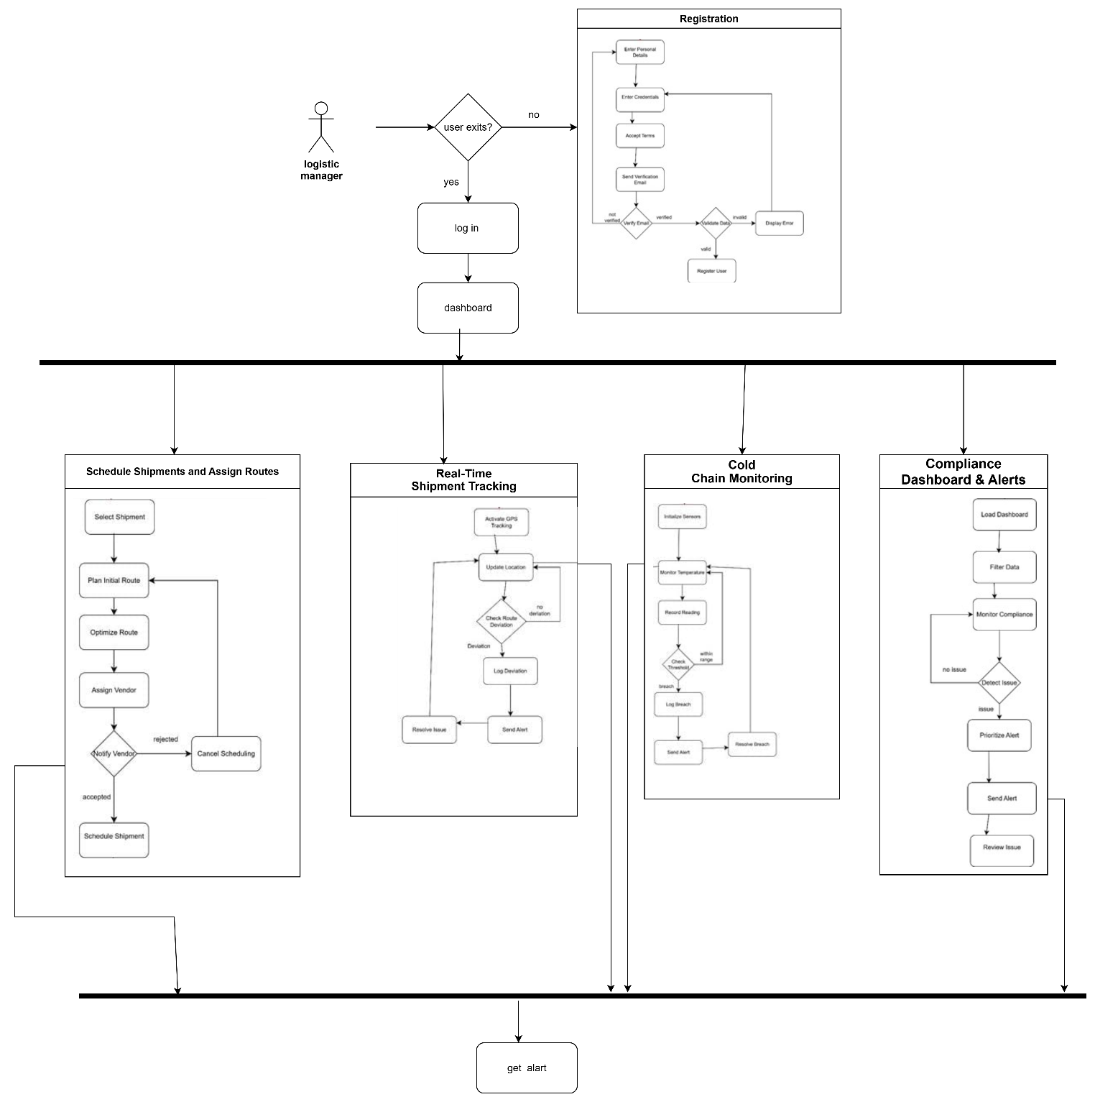

**7.2 Transport Vendor**

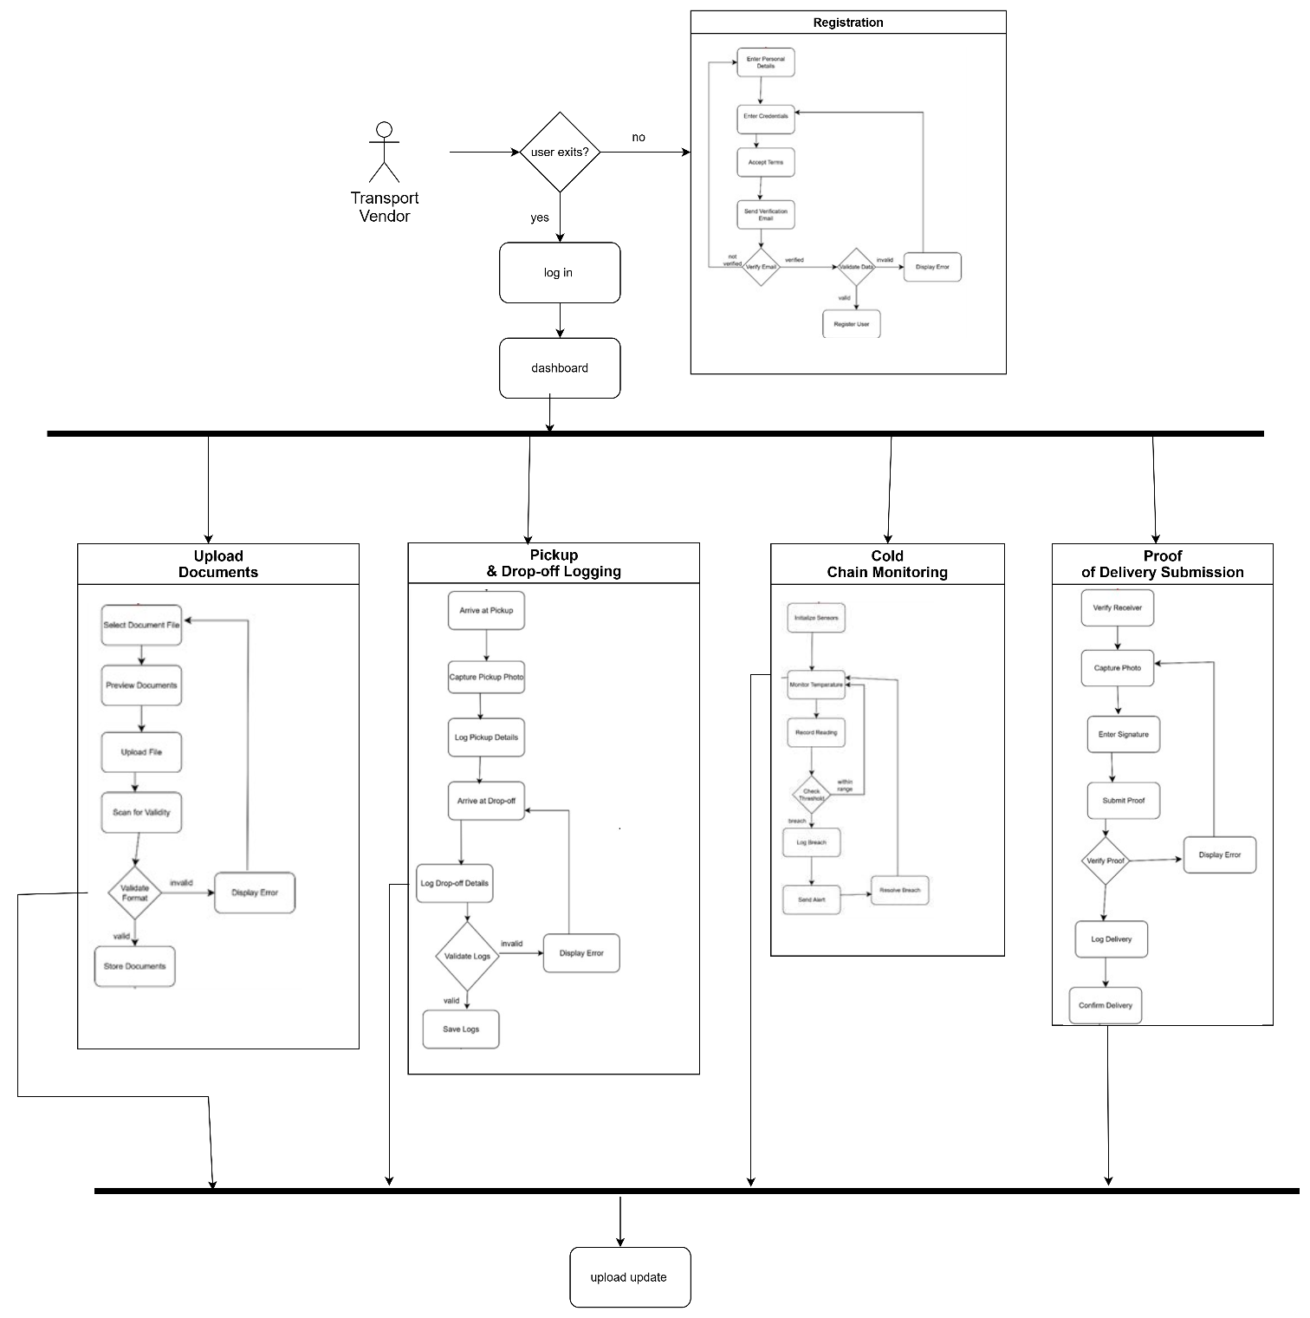

**7.3 System Admin**

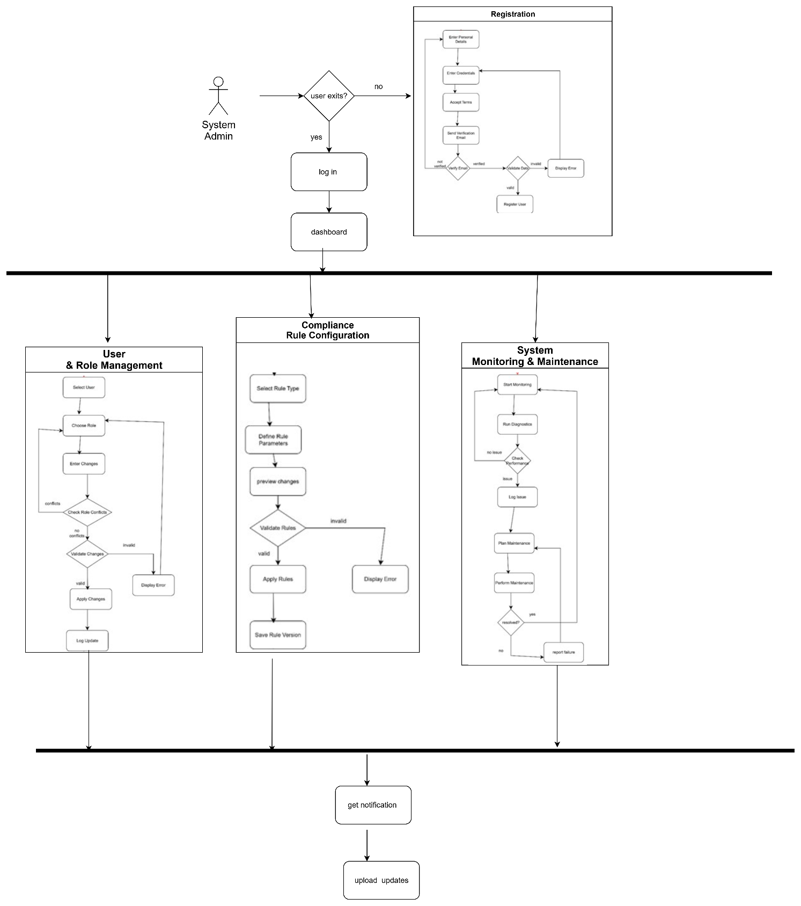

**8. Software Requirement Specification**

**8.1 SRS**

|  |  |
| --- | --- |
| FR01 | Registration |
| Description: | Before using the ChainGuard system, Logistics Managers, Transport Vendors, and System Admins must register first. |
| Stakeholder: | Logistics Manager, Transport Vendor, System Admin |

|  |  |
| --- | --- |
| FR02 | Login |
| Description: | All users (Logistics Manager, Transport Vendor, and System Admin) must log in to access system functionalities. |
| Stakeholder: | Logistics Manager, Transport Vendor, System Admin |

|  |  |
| --- | --- |
| FR03 | Schedule Shipments and Assign Routes |
| Description: | Logistics Managers can schedule deliveries and assign routes to transport vendors with expected delivery time. |
| Stakeholder: | Logistics Manager |

|  |  |
| --- | --- |
| FR04 | Upload Documents |
| Description: | Transport Vendors upload necessary documents such as vehicle permits, driver licenses, insurance, and hygiene reports. |
| Stakeholder: | Transport Vendor |

|  |  |
| --- | --- |
| FR05 | Real-Time Shipment Tracking |
| Description: | Logistics Managers can view the real-time GPS location of all in-transit deliveries and receive alerts on deviations. |
| Stakeholder: | Logistics Manager |

|  |  |
| --- | --- |
| FR06 | Cold Chain Monitoring |
| Description: | Transport Vendors must monitor and submit temperature logs manually or via IoT devices to maintain cold-chain integrity. |
| Stakeholder: | Transport Vendor, Logistics Manager |

|  |  |
| --- | --- |
| FR07 | Pickup & Drop-off Logging |
| Description: | Transport Vendors record timestamp and condition at pickup and drop-off points. |
| Stakeholder: | Transport Vendor |

|  |  |
| --- | --- |
| FR08 | Proof of Delivery Submission |
| Description: | Transport Vendors submit proof of delivery via photos, OTP, or digital receipts. |
| Stakeholder: | Transport Vendor |

|  |  |
| --- | --- |
| FR09 | Compliance Dashboard & Alerts |
| Description: | Logistics Managers receive alerts and monitor compliance such as document expiry, temperature breaches, and hygiene violations. |
| Stakeholder: | Logistics Manager |

|  |  |
| --- | --- |
| FR10 | User & Role Management |
| Description: | System Admins can add/remove users and assign roles with specific access privileges. |
| Stakeholder: | System Admin |

|  |  |
| --- | --- |
| FR11 | Compliance Rule Configuration |
| Description: | System Admins can set and update rules such as license expiry limits, acceptable temperature ranges, and required documents. |
| Stakeholder: | System Admin |

|  |  |
| --- | --- |
| FR12 | System Monitoring & Maintenance |
| Description: | System Admins are responsible for system updates, backups, and monitoring system performance. |
| Stakeholder: | System Admin |

**8.2 Use Case Diagram**

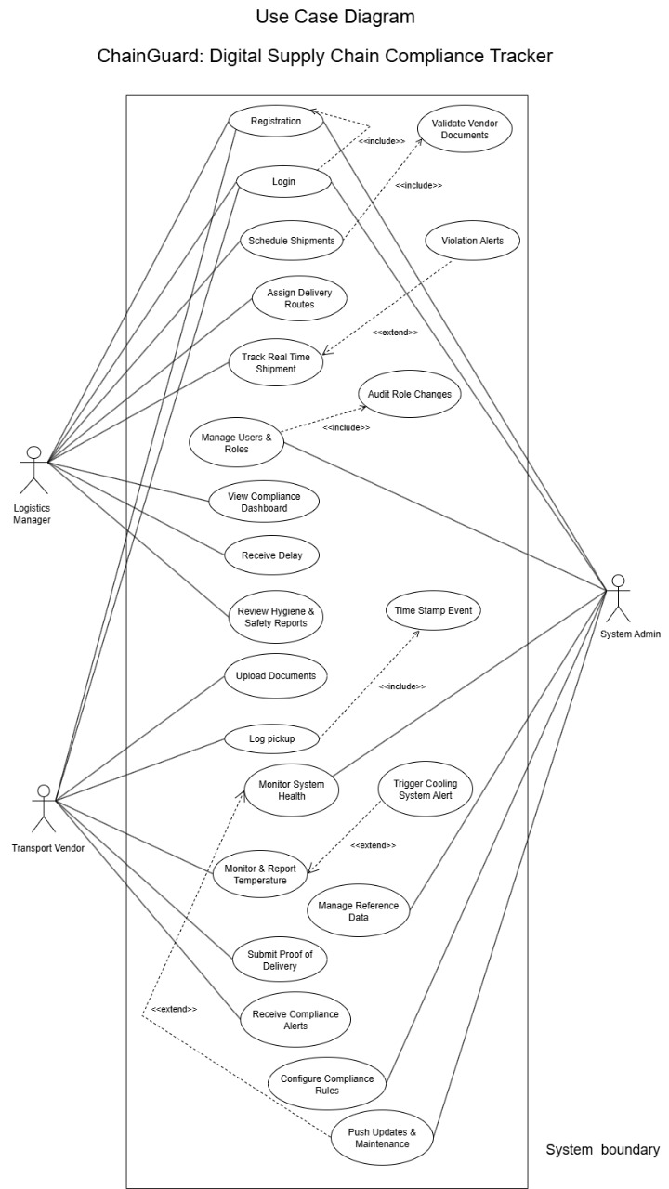

**8.3 Use Case Descriptions**

**8.3.1 Registration**

|  |  |
| --- | --- |
| Use Case | Registration |
| Goal | Users can register to access the ChainGuard system. |
| Precondition | User must install the ChainGuard mobile/web application. |
| Success End Condition | Notification: “Successfully Registered!” |
| Failed End Condition | Notification: “Registration Failed” |
| Primary Actors | Logistics Manager, Transport Vendor, System Admin |
| Secondary Actors | None |
| Trigger | User requests a registration form to fill up. |
| Description / Main Success Scenario | |  |  | | --- | --- | | 1. | Press “Registration” button. | | 2. | Provide registration form. | | 3. | Enter required information. | | 4. | Press “Submit” button. | | 5. | Information is validated. | | 6. | The system saves details and shows notification “Successfully Registered!” | |
| Alternative Flow | |  |  | | --- | --- | | 1.1. | System Error → 1.1.a Try again. | | 2.1. | System not responding → 2.1.a Try later. | | 3.1. | Missing required fields → 3.1.a System prompts “Please fill required fields”. | | 4.1. | Invalid OTP/email → 4.1.a Show error message. | | 5.1. | System does not save → 5.1.a Notification: “Details not saved”. | |
| Quality Requirements | User must complete registration within 10 minutes. |

**8.3.2 Login**

|  |  |
| --- | --- |
| Use Case | Login |
| Goal | Users can securely access ChainGuard features. |
| Precondition | User must be registered. |
| Success End Condition | Notification: “Login Successful!” |
| Failed End Condition | Notification: “Invalid Credentials” |
| Primary Actors | Logistics Manager, Transport Vendor, System Admin |
| Secondary Actors | None |
| Trigger | User presses “Login” button. |
| Description / Main Success Scenario | |  |  | | --- | --- | | 1. | Press “Login” button. | | 2. | Enter username and password. | | 3. | Enter OTP (if required). | | 4. | System validates details. | | 5. | System displays “Login Successful!” and grants access | |
| Alternative Flows | |  |  | | --- | --- | | 1.1 | Invalid credentials →  1.1.a System prompts “Invalid Username/Password”. | | 2.1. | Expired/Invalid OTP →  2.1.a Retry or resend OTP. | | 3.1. | System not responding →  3.1.a Show error message. | |
| Quality Requirements | User must log in within 5 minutes. |

**8.3.3 Schedule Shipments and Assign Routes**

|  |  |
| --- | --- |
| Use Case | Schedule Shipment and Assign Routes |
| Goal | Logistics Manager can schedule deliveries and assign routes |
| Precondition | Vendors must be registered and active. |
| Success End Condition | Notification: “Shipment Scheduled Successfully!” |
| Failed End Condition | Notification: “Shipment Scheduling Failed” |
| Primary Actors | Logistics Manager |
| Secondary Actors | Transport Vendor |
| Trigger | Manager selects “Schedule Shipment.” |
| Description / Main Success Scenario | |  |  | | --- | --- | | 1. | Manager selects shipment details. | | 2. | Assigns route and transport vendor. | | 3. | Defines estimated delivery time. | | 4. | Confirms and saves. | | 5. | System sends notification to vendor. | |
| Alternative Flows | |  |  | | --- | --- | | 1.1. | Vendor unavailable → 1.1.a System suggests alternate vendor. | | 2.1. | Invalid route → 2.1.a Prompt manager to reselect | | 3.1. | System error → 3.1.a Notification: “Try Again Later”. | |
| Quality Requirements | Shipment scheduling must be completed within 5 minutes. |

**8.3.4 Upload Documents**

|  |  |
| --- | --- |
| Use Case | Upload Documents |
| Goal | Transport Vendors upload compliance-related documents. |
| Precondition | Vendor must be logged in. |
| Success End Condition | Notification: “Document Uploaded Successfully” |
| Failed End Condition | Notification: “Upload Failed” |
| Primary Actors | Transport Vendor |
| Secondary Actors | Logistics Manager |
| Trigger | Vendor selects “upload document” |
| Description / Main Success Scenario | |  |  | | --- | --- | | 1. | Vendor chooses document type (license, permit, insurance). | | 2. | Uploads file. | | 3. | System timestamps and verifies file. | | 4. | System confirms successful upload. | |
| Alternative Flows | |  |  | | --- | --- | | 1.1. | Expired/invalid document → 1.1.a Notification: “Document Invalid”. | | 2.1. | Unsupported file → 2.1.a System rejects file. | | 3.1. | Network/system. error → 3.1.a Notification: “Upload Failed, Try Again”. | |
| Quality Requirements | Document upload must complete within 3 minutes. |

**8.3.5 Real-Time Shipment**

|  |  |
| --- | --- |
| Use Case | Real-Time Shipment Tracking |
| Goal | Logistics Managers track shipment location. |
| Precondition | Shipment must be active. |
| Success End Condition | Shipment location displayed on dashboard. |
| Failed End Condition | Notification: “Tracking Failed” |
| Primary Actors | Logistics Managers |
| Secondary Actors | Transport Vendor |
| Trigger | Manager selects shipment tracking. |
| Description / Main Success Scenario | |  |  | | --- | --- | | 1. | System fetches GPS data. | | 2. | Displays shipment location on map. | | 3. | Sends alerts for route deviations. | |
| Alternative Flows | |  |  | | --- | --- | | 1.1. | GPS signal lost →  1.1.a Display last known location. | | 2.1. | Network unavailable →  2.1.a Show offline data until sync. | |
| Quality Requirements | GPS update within 30 seconds. |

**8.3.6 Cold Chain Monitoring**

|  |  |
| --- | --- |
| Use Case | Cold Chain Monitoring |
| Goal | Ensure medicines remain within safe temperature range. |
| Precondition | Shipment must be ongoing. |
| Success End Condition | Notification: “Temperature Normal” |
| Failed End Condition | Alert: “Temperature Breach” |
| Primary Actors | Transport Vendor, Logistics Manager |
| Secondary Actors | IoT Sensor. |
| Trigger | Temperature data received. |
| Description / Main Success Scenario | |  |  | | --- | --- | | 1. | IoT device/manual entry records temperature. | | 2. | System stores log. | | 3. | If within range → continue. | | 4. | If out of range → alert manager. | |
| Alternative Flows | |  |  | | --- | --- | | 1.1. | IoT failure →  1.1.a Manual entry required. | | 2.1. | Data sync error →  2.1.a Store locally until connection restores. | |
| Quality Requirements | System must alert within 10 seconds of breach. |

**8.3.7 Pickup & Drop-off Logging**

|  |  |
| --- | --- |
| Use Case | Pickup & Drop-off Logging |
| Goal | Record pickup and delivery checkpoints. |
| Precondition | Shipment scheduled. |
| Success End Condition | Logs saved successfully. |
| Failed End Condition | Notification: “Log Failed” |
| Primary Actors | Transport Vendor |
| Secondary Actors | Logistics Manager |
| Trigger | Vendor marks pickup/drop-off. |
| Description / Main Success Scenario | |  |  | | --- | --- | | 1. | Vendor logs pickup with timestamp and location. | | 2. | Vendor logs drop-off with condition status. | | 3. | System updates records. | |
| Alternative Flows | |  |  | | --- | --- | | 1.1. | Vendor skips logging →  1.1.a Alert manager. | | 2.1. | Network failure →  2.1.a Store offline and sync later. | |
| Quality Requirements | Logs must sync within 1 minute of connectivity restoration. |

**8.3.8 Proof of Delivery Submission**

|  |  |
| --- | --- |
| Use Case | Proof of Delivery Submission |
| Goal | Confirm delivery completion. |
| Precondition | Shipment delivered. |
| Success End Condition | Proof saved successfully. |
| Failed End Condition | Notification: “Proof Submission Failed” |
| Primary Actors | Transport Vendor |
| Secondary Actors | Receiver, Logistics Manager |
| Trigger | Vendor submits proof. |
| Description / Main Success Scenario | |  |  | | --- | --- | | 1. | Vendor selects proof option (photo, signature, OTP). | | 2. | Uploads or enters proof. | | 3. | System verifies and saves. | |
| Alternative Flows | |  |  | | --- | --- | | 1.1. | Invalid OTP → 1.1.a Prompt retry. | | 2.1. | Upload failure → 2.1.a Notification: “Try Again”. | |
| Quality Requirements | Proof submission must complete within 2 minutes. |

**8.3.9 Compliance Dashboard & Alerts**

|  |  |
| --- | --- |
| Use Case | Compliance Dashboard & Alerts |
| Goal | Monitor shipment compliance and alerts. |
| Precondition | Active shipments and uploaded data exist. |
| Success End Condition | Dashboard displays real-time compliance. |
| Failed End Condition | Notification: “Dashboard Error” |
| Primary Actors | Logistics Manager |
| Secondary Actors | None |
| Trigger | Manager opens dashboard. |
| Description / Main Success Scenario | |  |  | | --- | --- | | 1. | System gathers compliance data. | | 2. | Displays KPIs and metrics. | | 3. | Sends alerts for violations. | |
| Alternative Flows | |  |  | | --- | --- | | 1.1. | System error →  1.1.a Retry later. | | 2.1. | Data missing →  2.1.a Display warning. | |
| Quality Requirements | Dashboard refresh every 1 minute. |

**8.3.10 User & Role Management**

|  |  |
| --- | --- |
| Use Case | User & Role Management |
| Goal | Admin manages user accounts and roles. |
| Precondition | Admin logged in. |
| Success End Condition | Roles updated successfully. |
| Failed End Condition | Notification: “Update Failed” |
| Primary Actors | System Admin |
| Secondary Actors | None |
| Trigger | Admin selects “Manage Users.” |
| Description / Main Success Scenario | |  |  | | --- | --- | | 1. | Admin views user list. | | 2. | Adds/edits/deletes user. | | 3. | Assigns role. | | 4. | Saves changes. | |
| Alternative Flows | |  |  | | --- | --- | | 1.1. | Invalid input →  1.1.a Prompt retry. | | 2.1. | System error →  2.1.a Notification: “Try Again Later”. | |
| Quality Requirements | Role updates must take effect instantly. |

**8.3.11 Compliance Rule Configuration**

|  |  |
| --- | --- |
| Use Case | Compliance Rule Configuration |
| Goal | Update compliance rules. |
| Precondition | Admin logged in. |
| Success End Condition | Rules updated successfully. |
| Failed End Condition | Notification: “Configuration Failed” |
| Primary Actors | System Admin |
| Secondary Actors | None |
| Trigger | Admin selects “Rule Configuration.” |
| Description / Main Success Scenario | |  |  | | --- | --- | | 1. | Admin selects rule type (temperature, license, expiry). | | 2. | Updates requirements. | | 3. | Saves changes. | | 4. | System applies rules immediately. | |
| Alternative Flows | |  |  | | --- | --- | | 1.1. | Invalid input →  1.1.a Prompt admin to correct. | | 2.1. | System error →  2.1.a Retry later. | |
| Quality Requirements | Rules must apply across all shipments instantly. |

**8.3.12 System Monitoring & Maintenance**

|  |  |
| --- | --- |
| Use Case | System Monitoring & Maintenance |
| Goal | Ensure system health, security, and backups. |
| Precondition | Admin logged in. |
| Success End Condition | System runs “Successfully”. |
| Failed End Condition | Notification: “Maintenance Failed” |
| Primary Actors | System Admin |
| Secondary Actors | None |
| Trigger | Admin selects “System Monitoring.” |
| Description / Main Success Scenario | |  |  | | --- | --- | | 1. | Admin views performance logs. | | 2. | Runs system checks. | | 3. | Applies backups. | | 4. | Confirms system stability. | |
| Alternative Flows | |  |  | | --- | --- | | 1.1. | Backup fails →  1.1.a Retry backup. | | 2.1. | Update error →  2.1.a Rollback changes. | |
| Quality Requirements | System uptime must be ≥ 99.5%. |

**9. System Design**

**9.1 Data Flow Diagram**

**9.1.1 Data Flow Diagram Level-0**

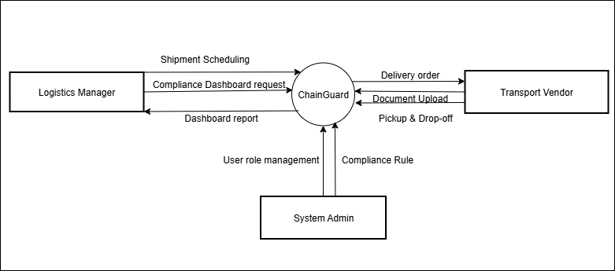

**9.1.2 Data Flow Diagram Level-1**

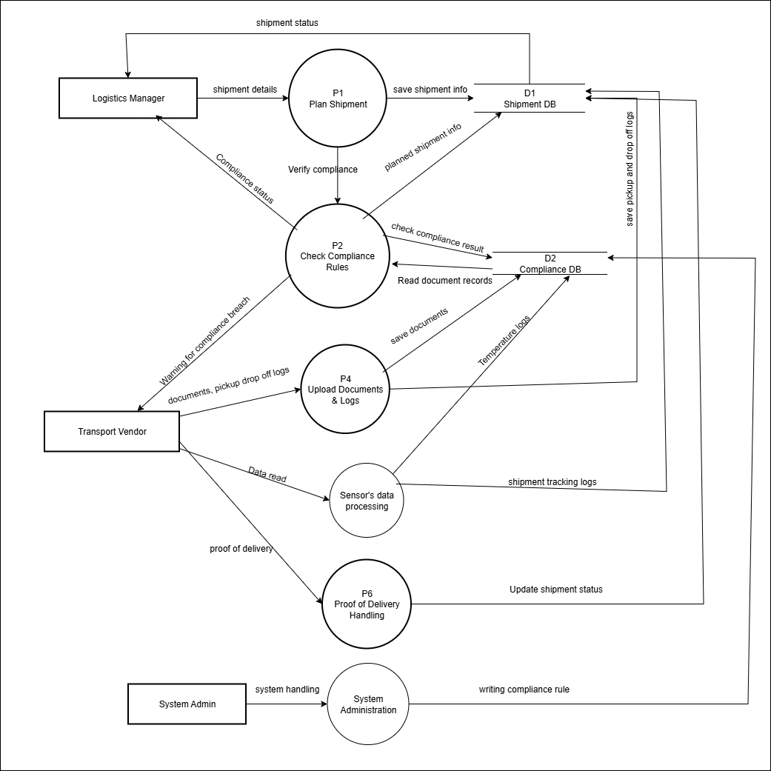

**9.1.3 Data Flow Diagram Level-2**

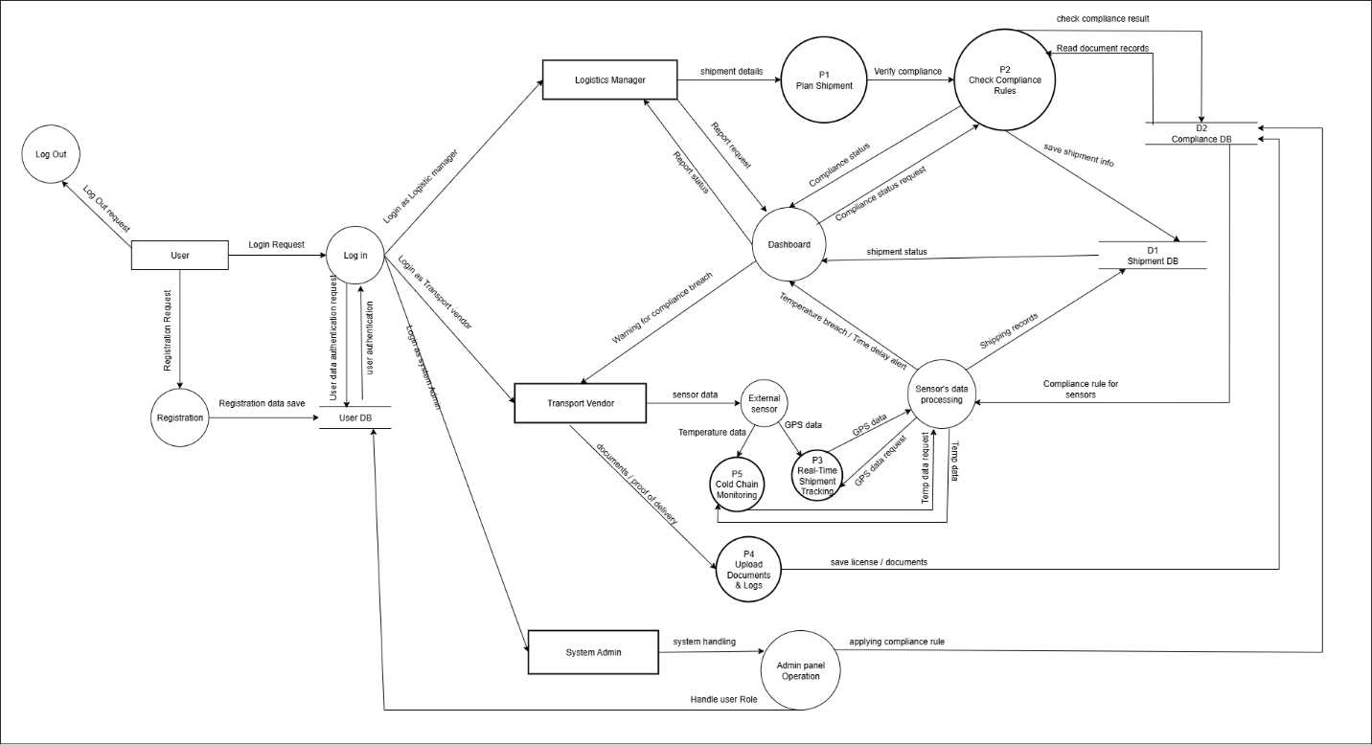

**9.2 Activity Diagram**

**9.2.1 register**

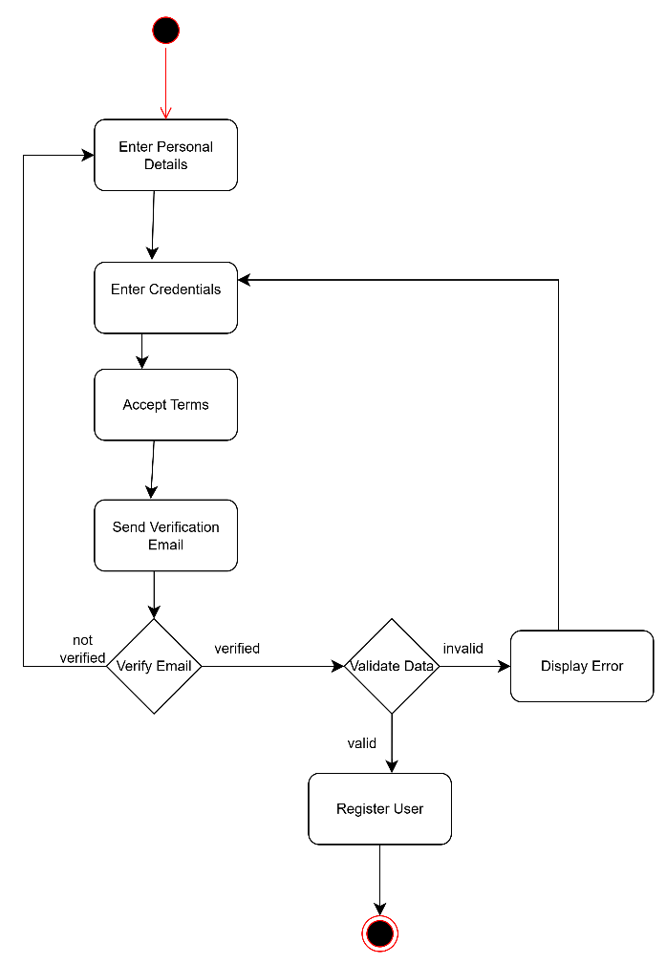

**9.2.2 login**

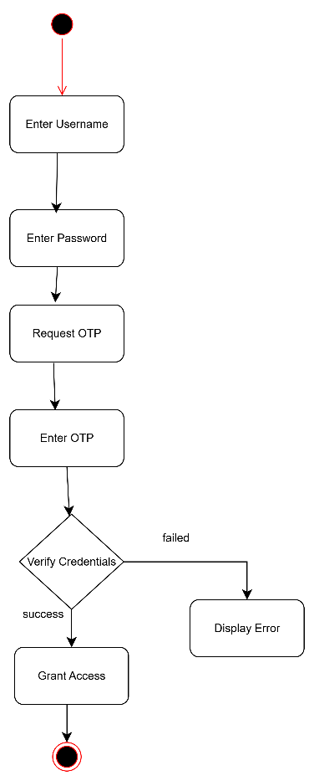

**9.2.3 Schedule Shipments and Assign Routes**

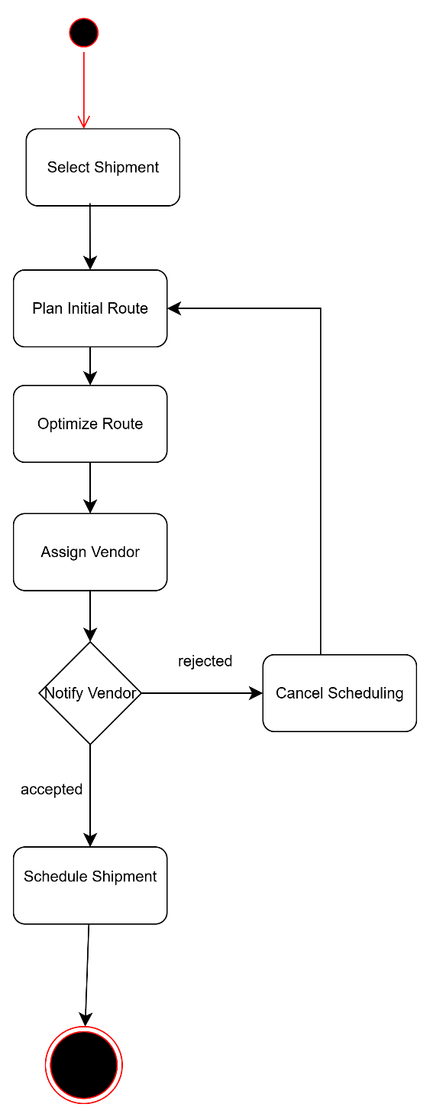

**9.2.4 Upload Documents**

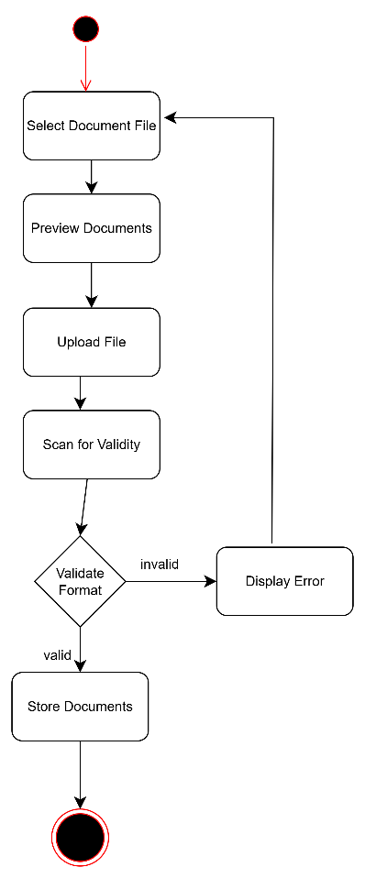

**9.2.5 Real-Time Shipment Tracking**

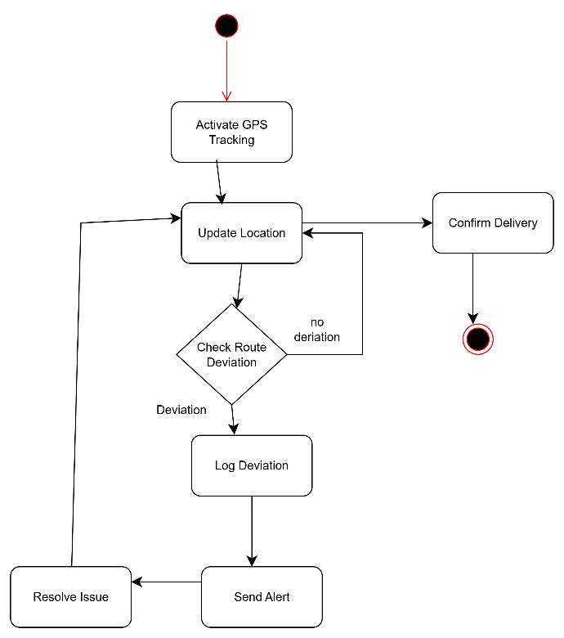

**9.2.6 Cold Chain Monitoring**

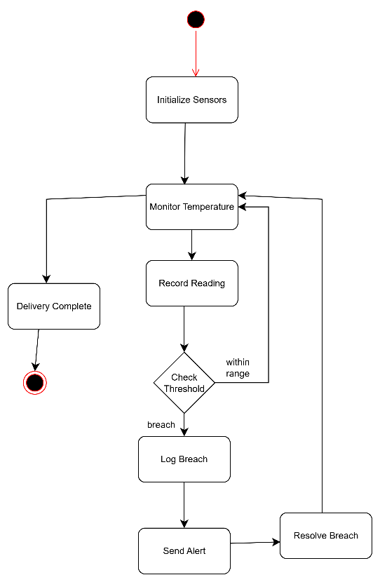

**9.2.7 Pickup & Drop-off Logging**

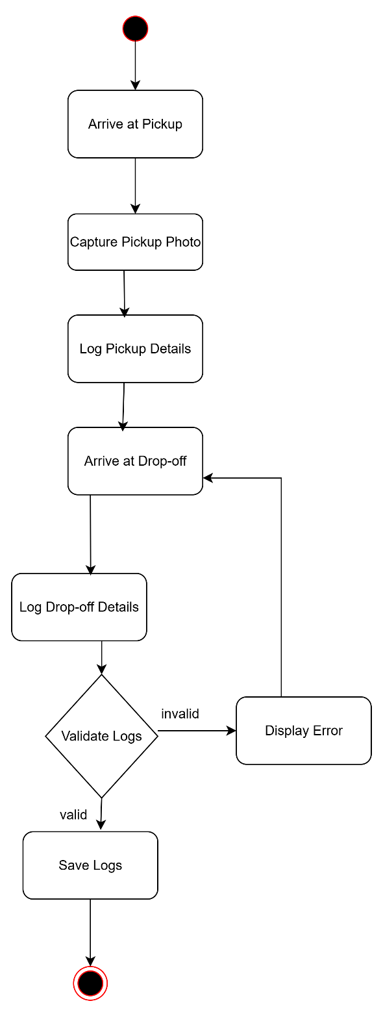

**9.2.8 Proof of Delivery Submission**

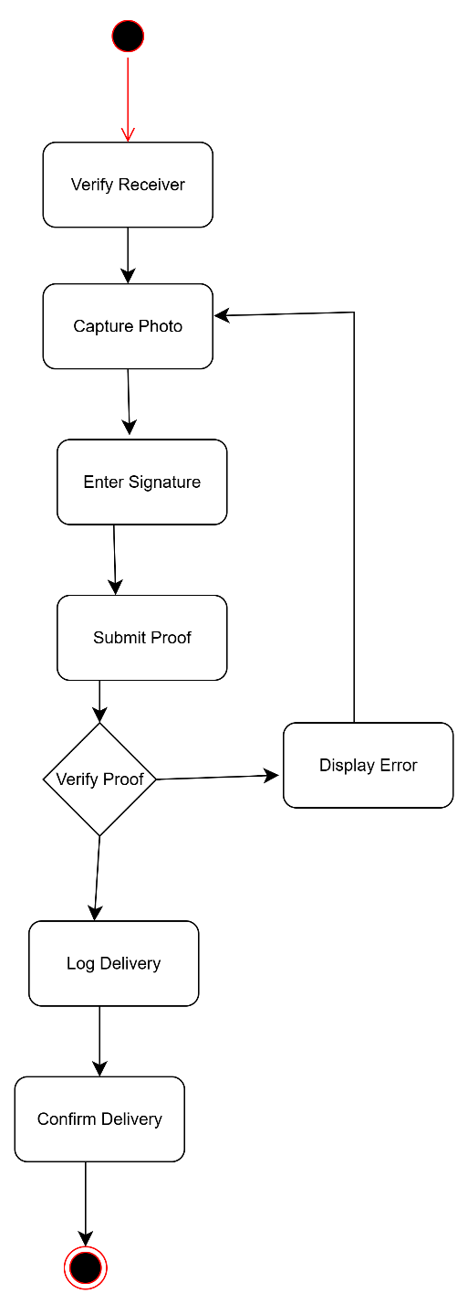

**9.2.9 Compliance Dashboard & Alerts**

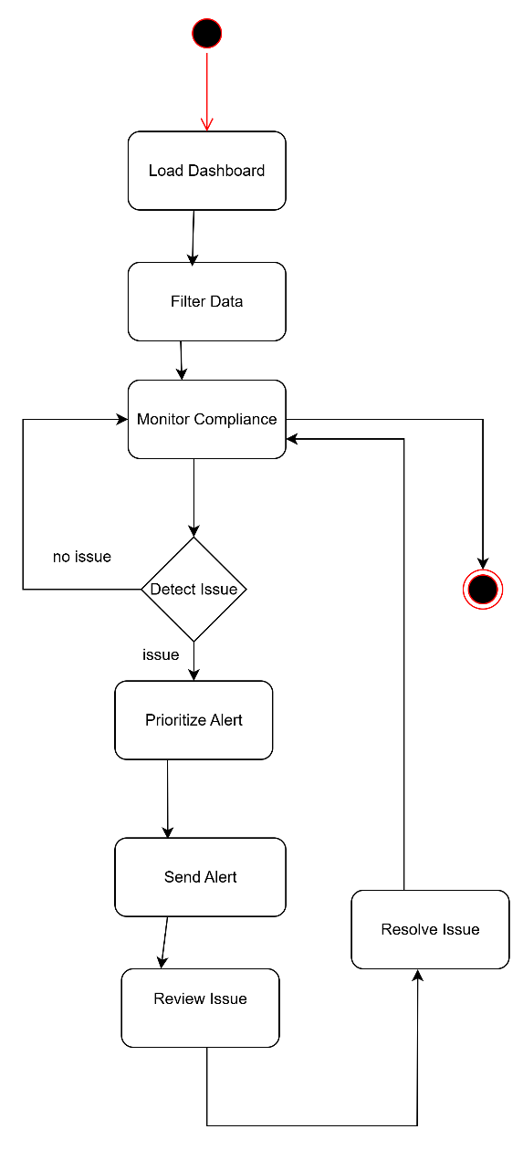

**9.2.10 User & Role Management**

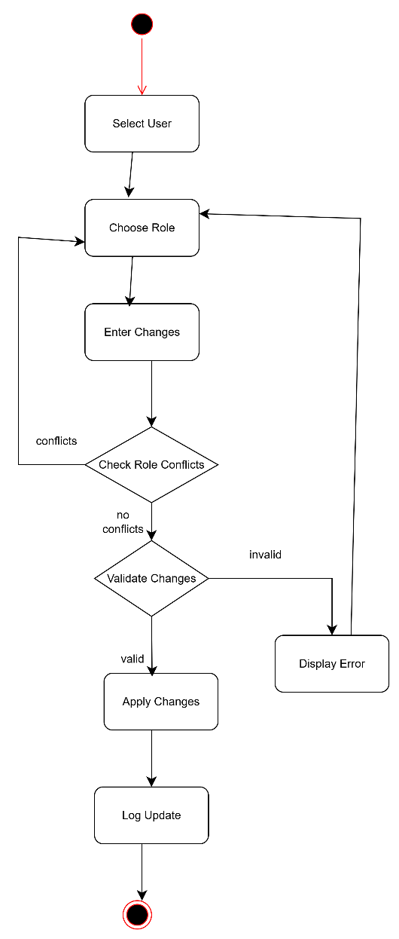

### 9.2.11 Compliance Rule Configuration

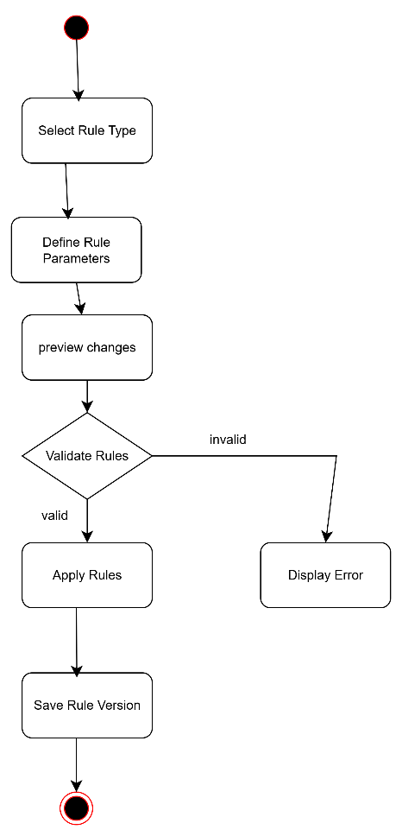

**9.2.12 System Monitoring & Maintenance**

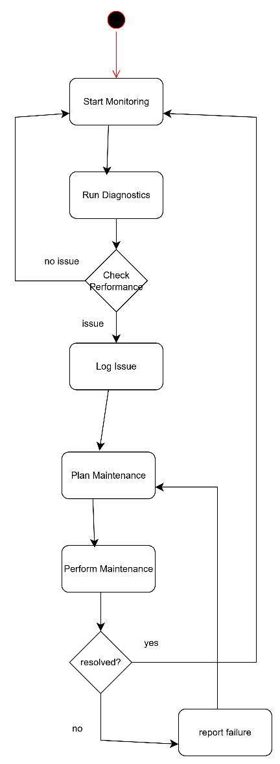

**9.3 State Diagram**

**9.3.1 Registration**

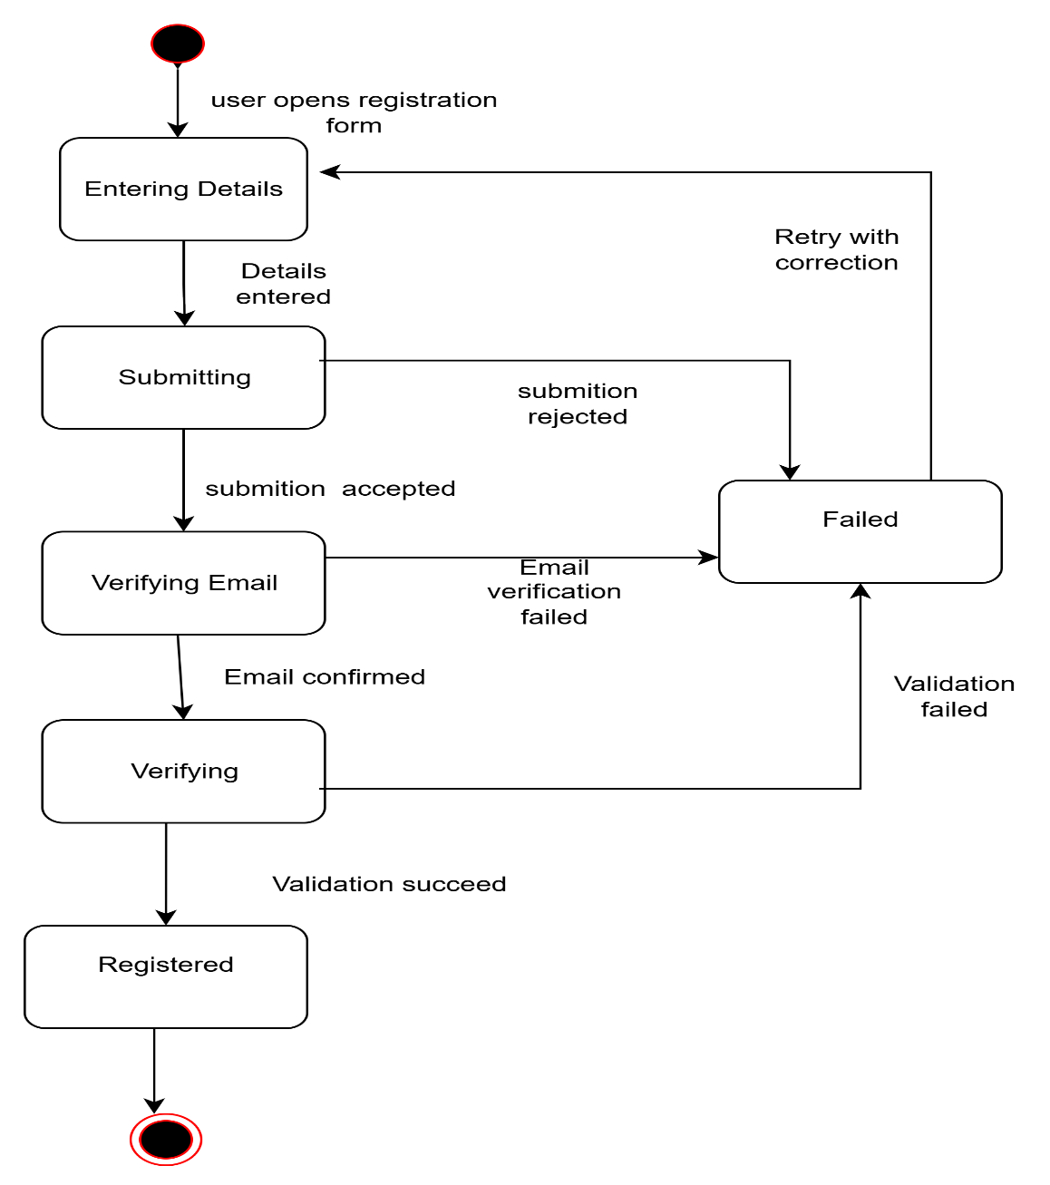

**9.3.2 log in**

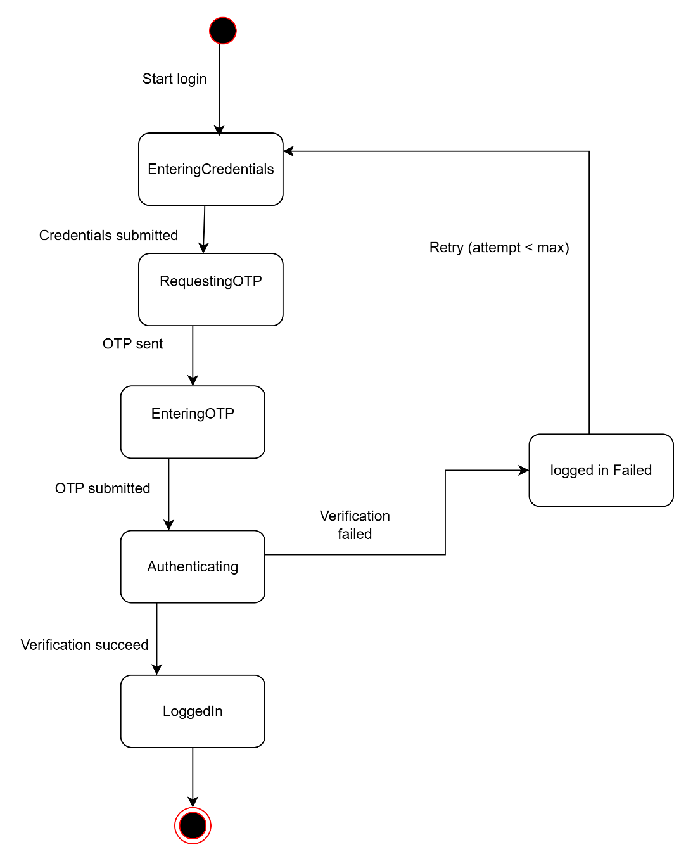

**9.3.3 Schedule Shipments and Assign Routes**

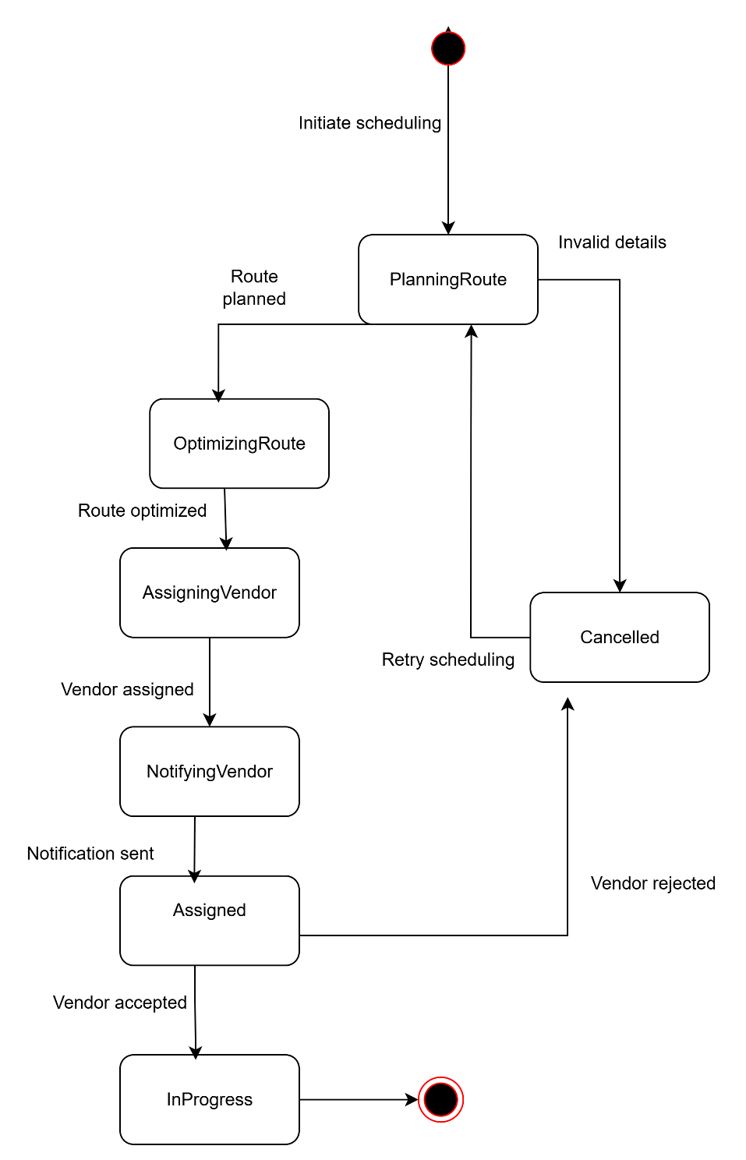

**9.3.4 Upload Documents**

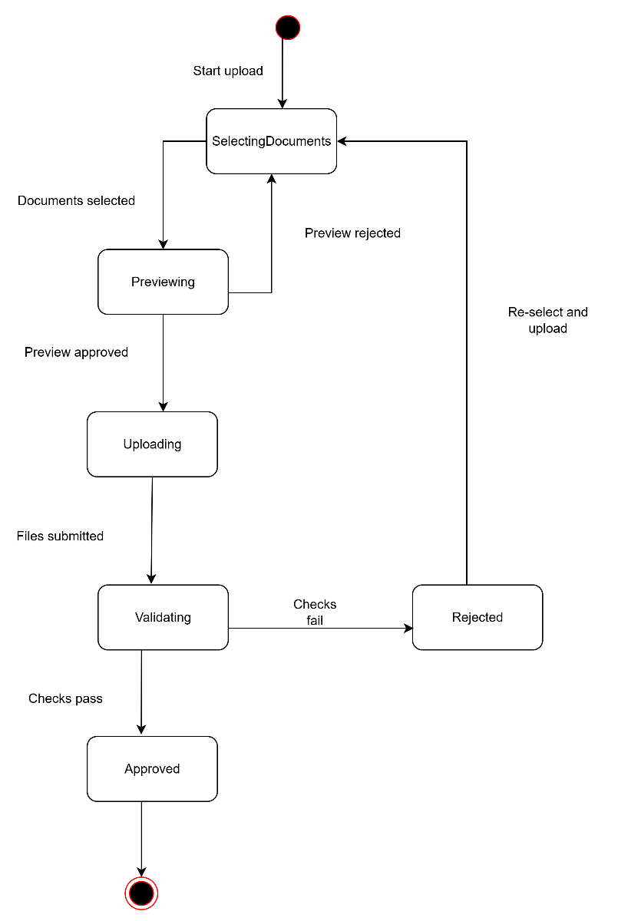

**9.3.5 Real-Time Shipment Tracking:**

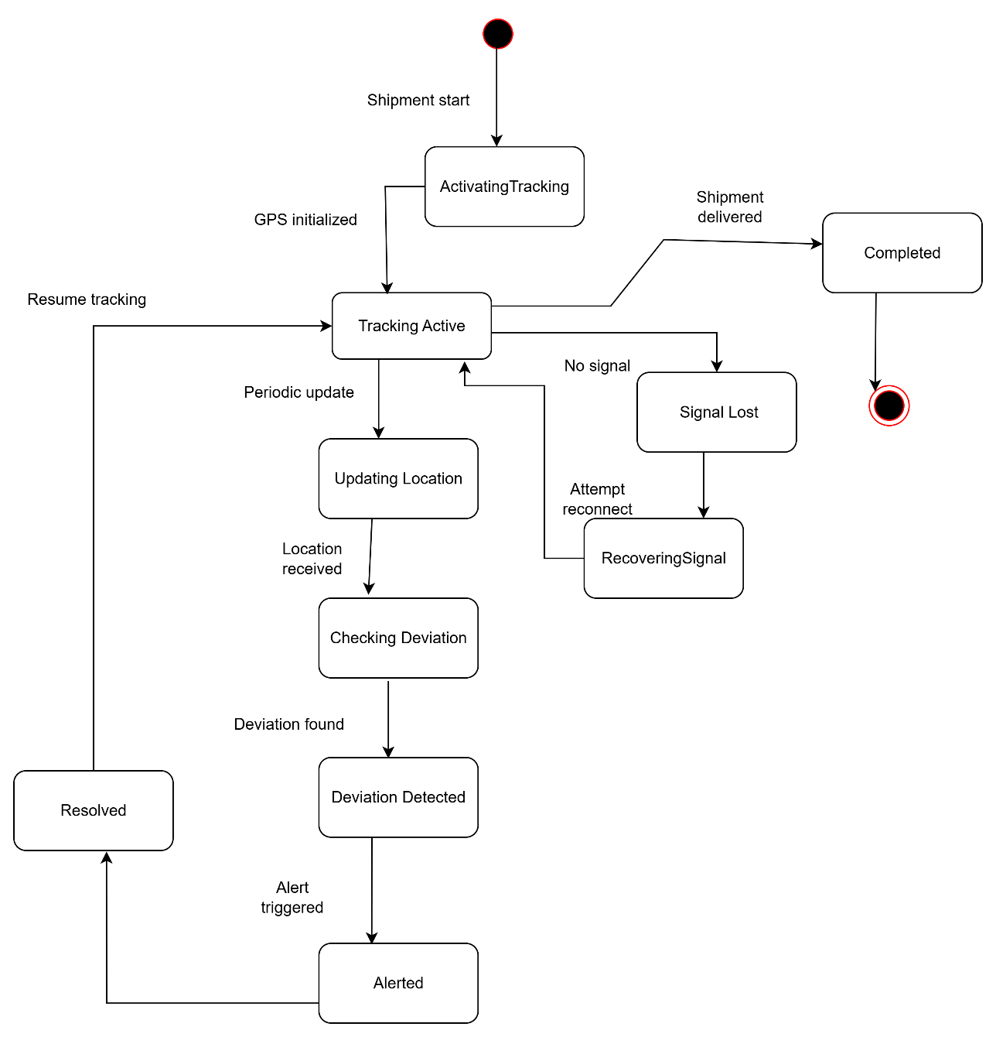

**9.3.6 Cold Chain Monitoring**

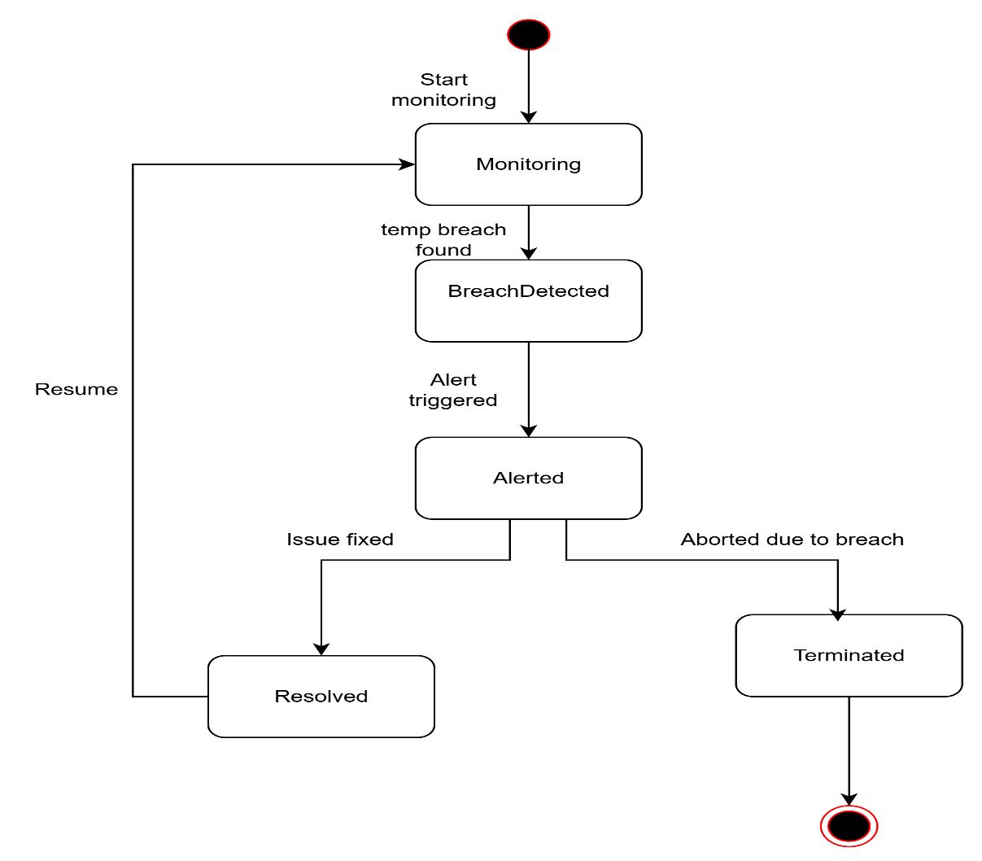

**9.3.7 Pickup & Drop-off Logging:**

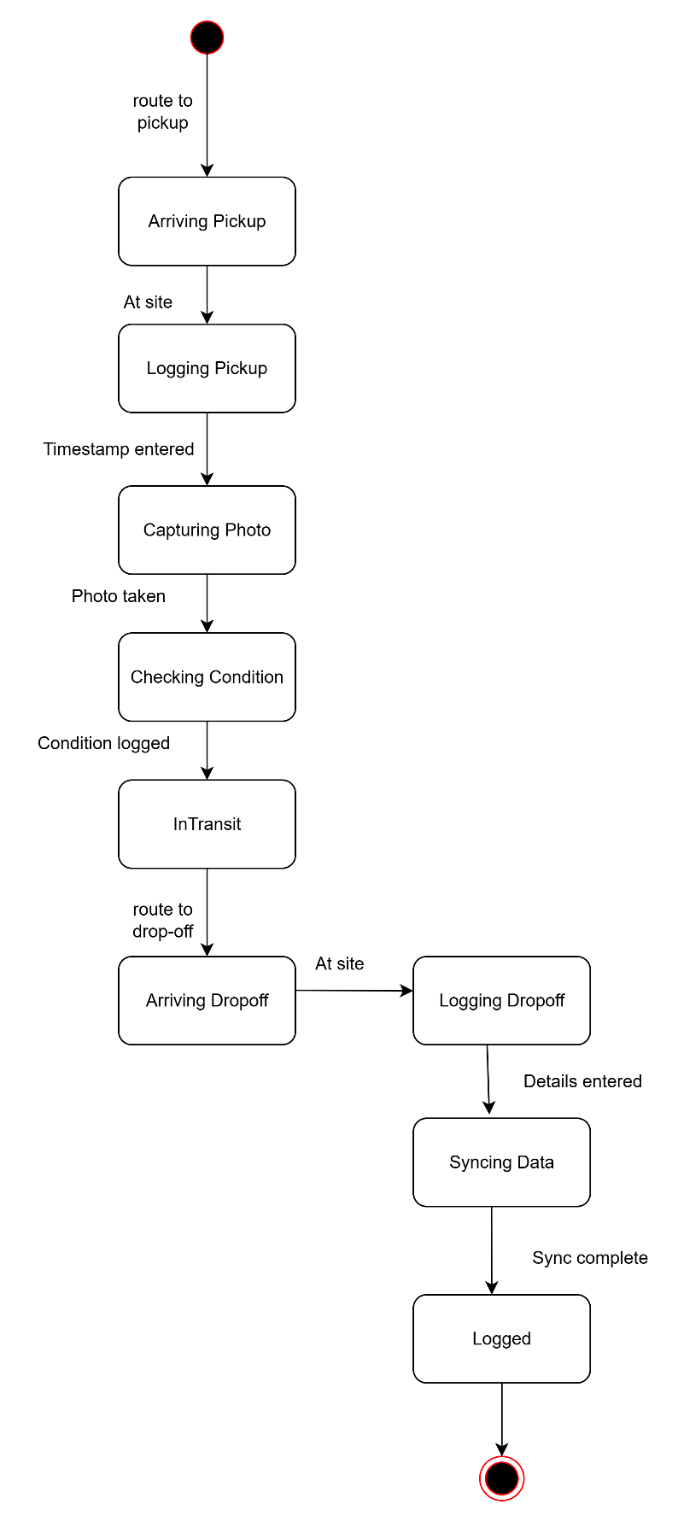

**9.3.8 Proof of Delivery Submission**

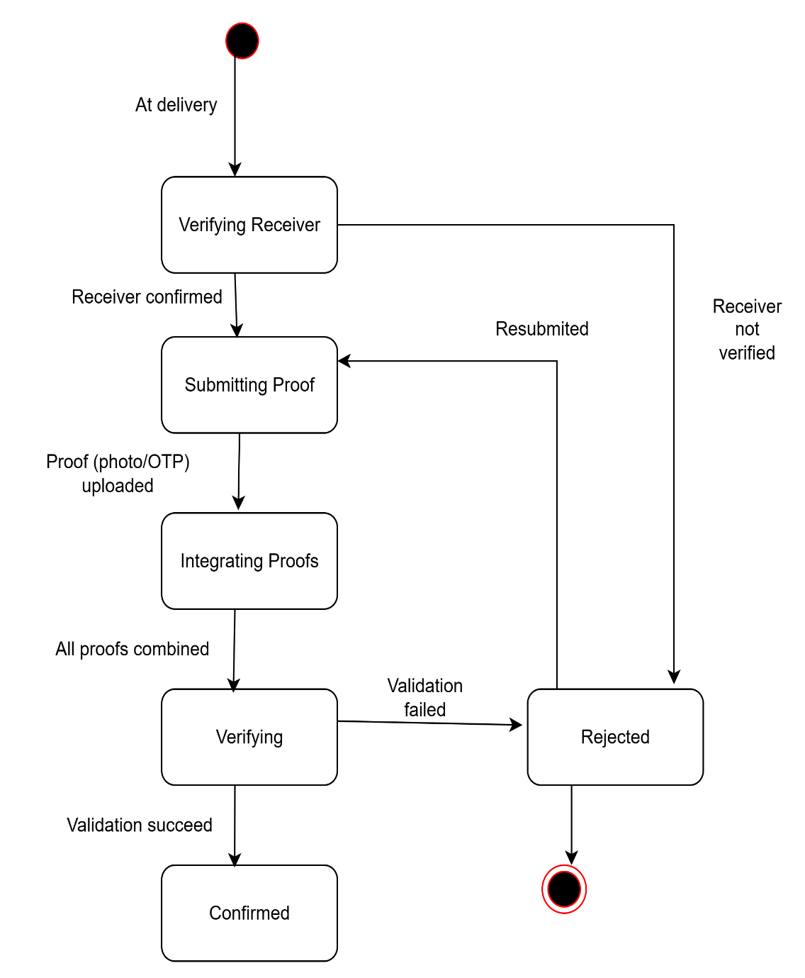

**9.3.9 Compliance Dashboard & Alerts**

### 

**9.3.10 User & Role Management**

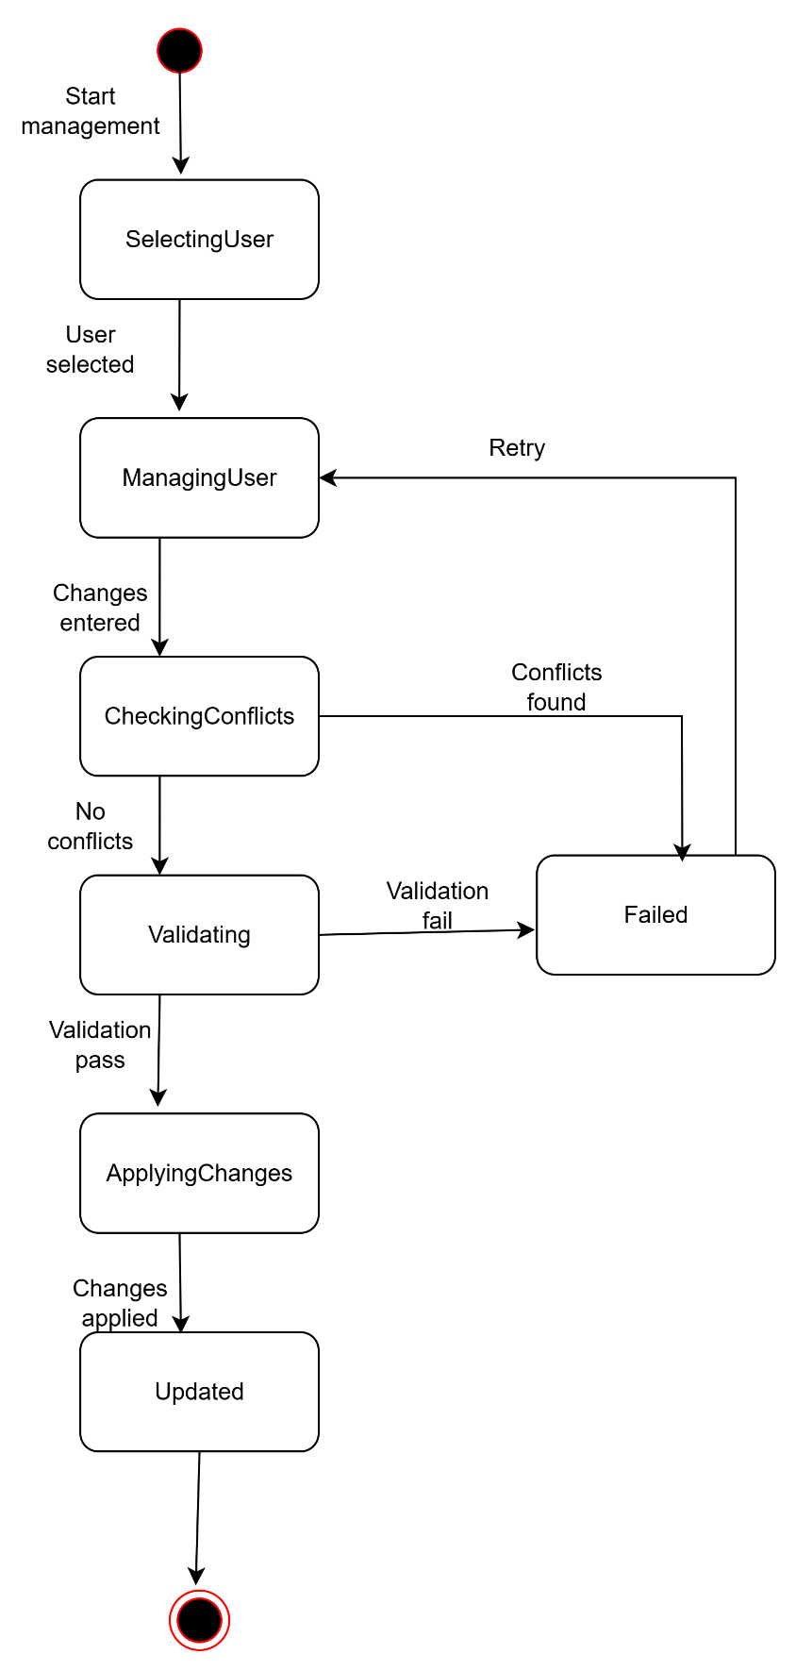

**9.3.11 Compliance Rule Configuration**

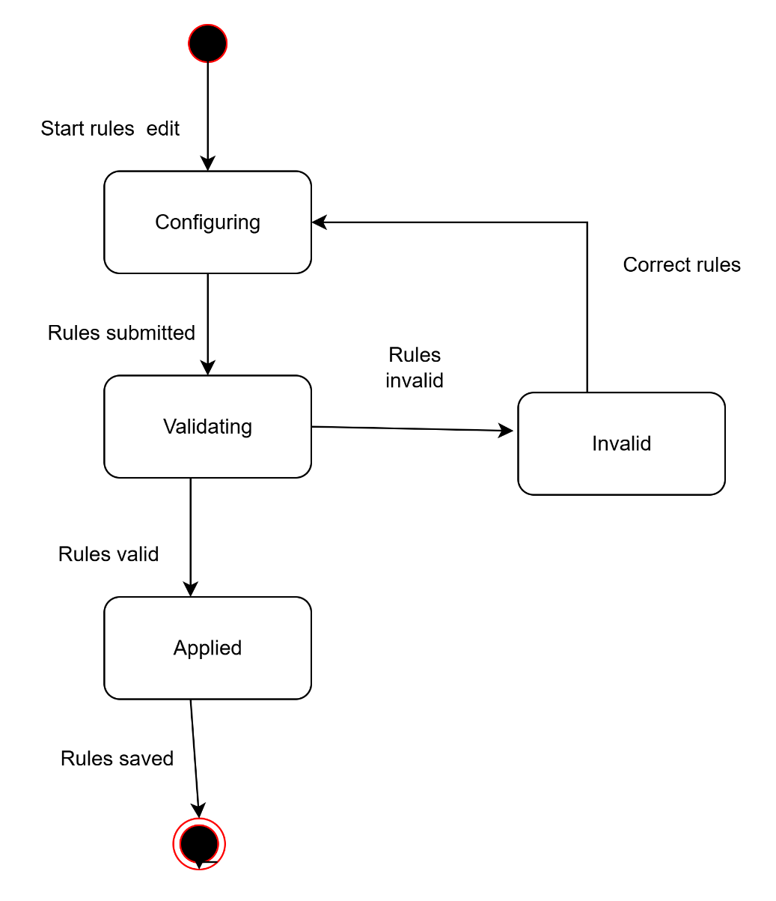

**9.3.12 System Monitoring & Maintenance**

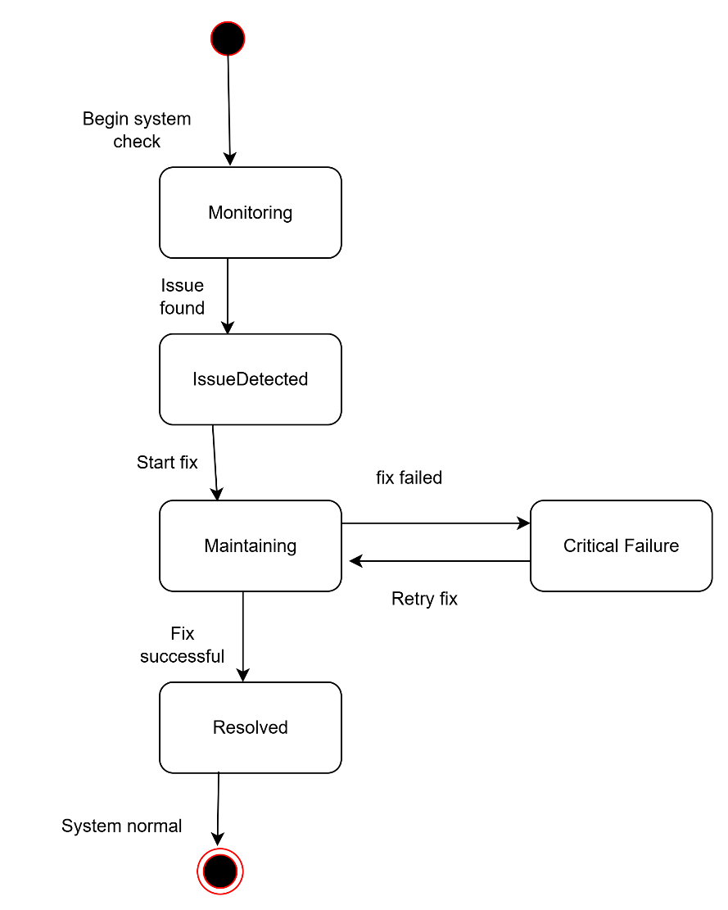

**9.4 Sequence Diagram**

**9.4.1 Registration**

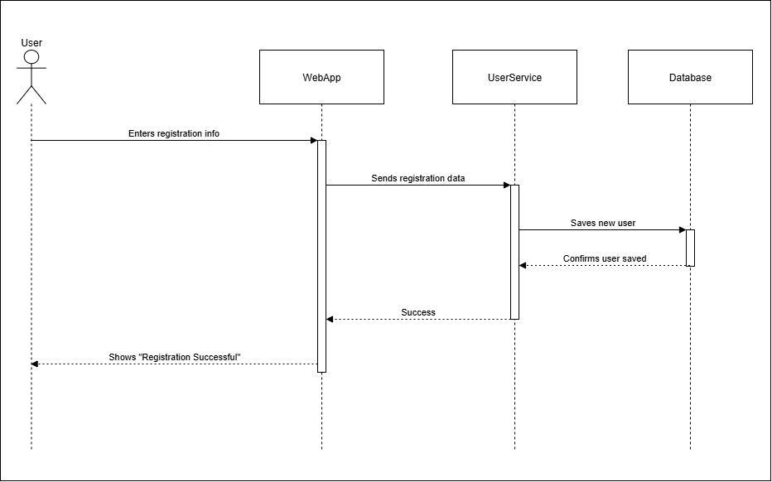

**9.4.2 Login**

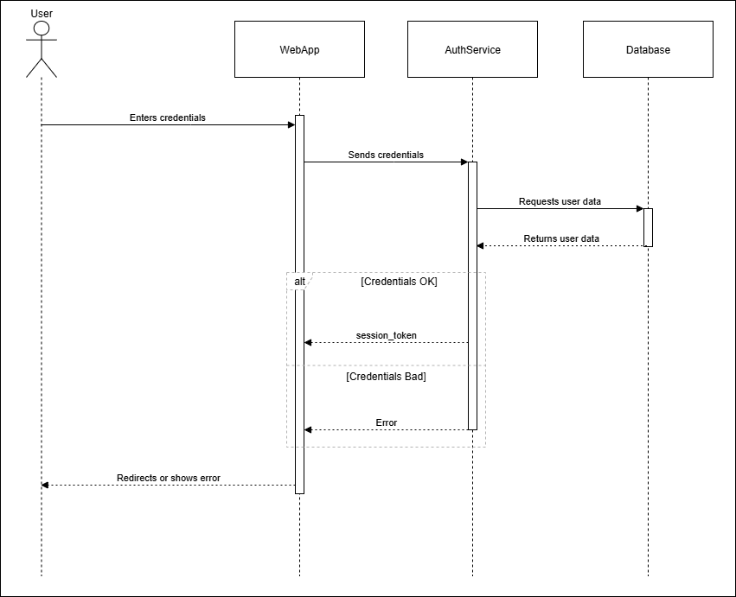

**9.4.3 Schedule Shipments and Assign Routes**

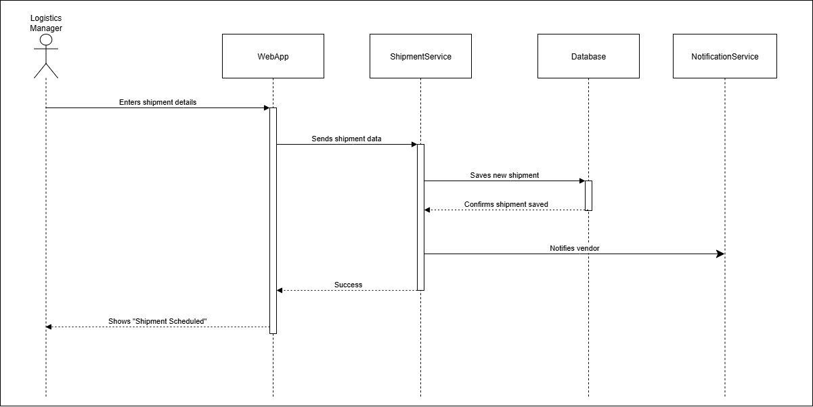

**9.4.4Upload Documents**

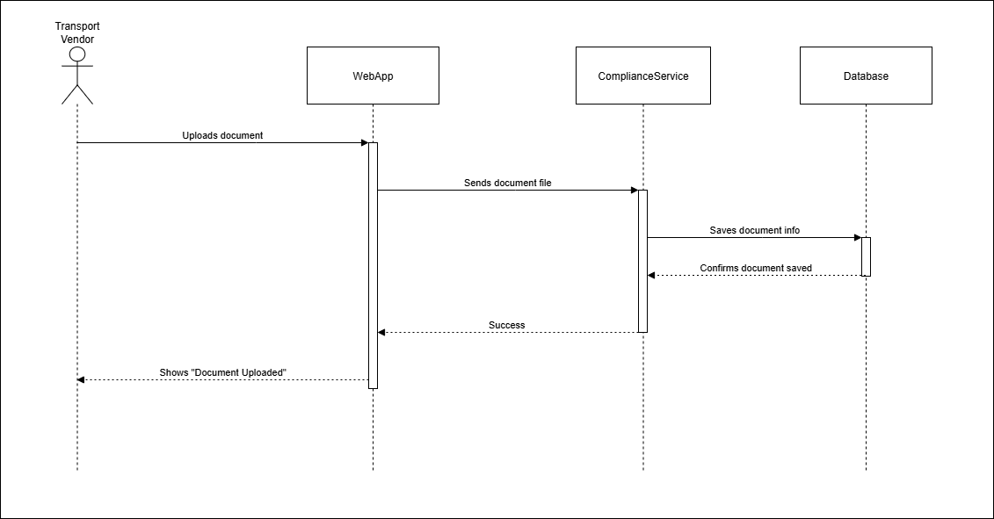

**9.4.5 Real-Time Shipment Tracking**

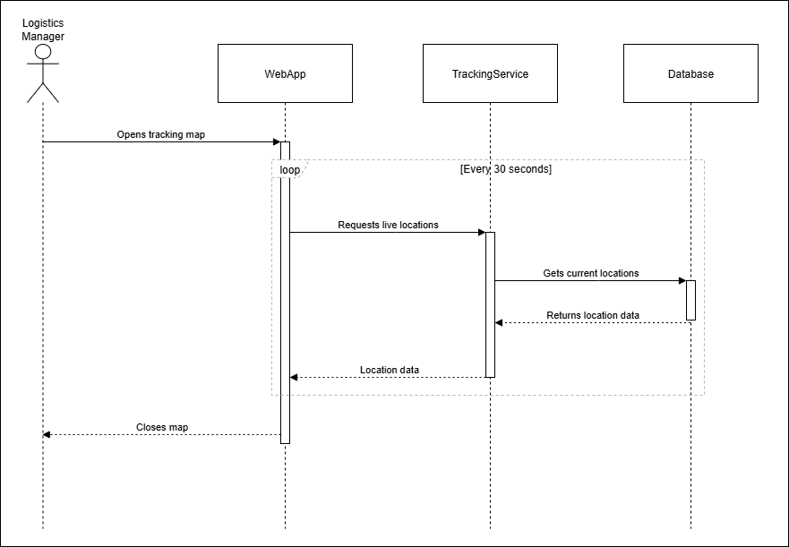

**9.4.6 Cold Chain Monitoring**

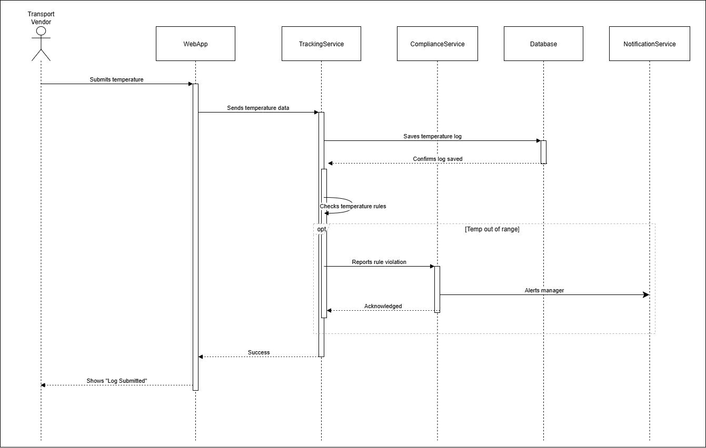

**9.4.7 Pickup & Drop-off Logging**

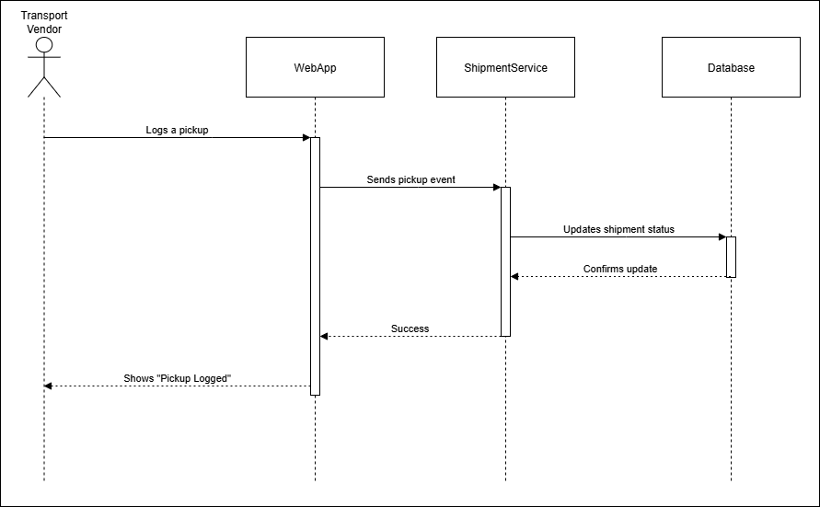

**9.4.8 Proof of Delivery Submission**

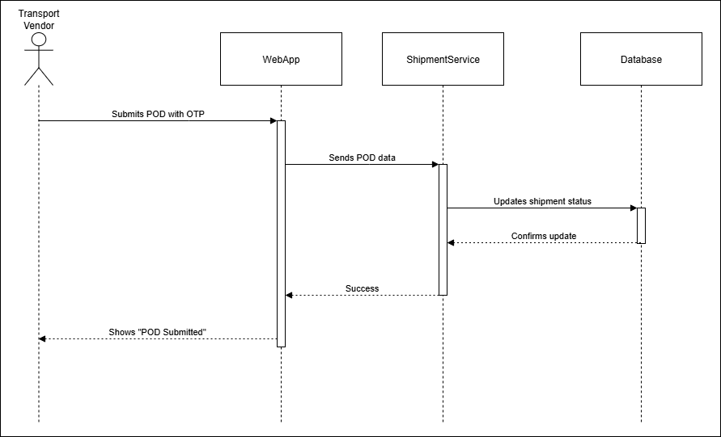

**9.4.9 Compliance Dashboard & Alerts**

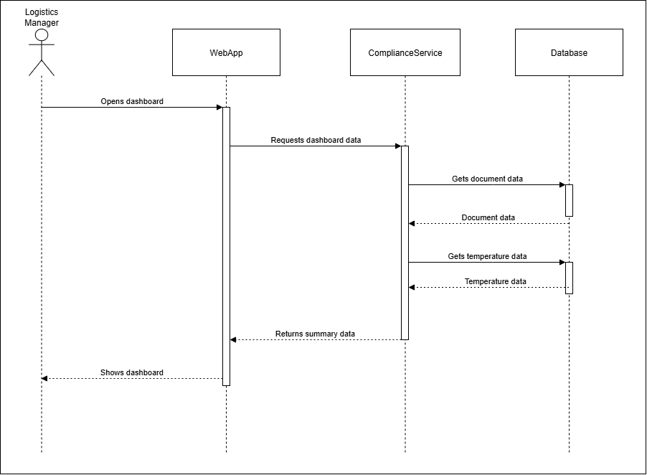

**9.4.10 User & Role Management**

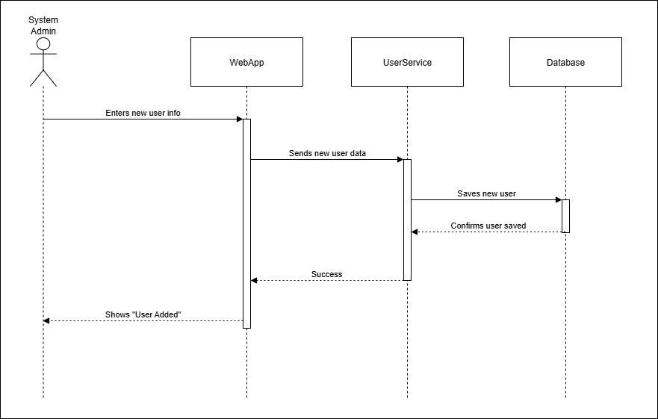

**9.4.11 Compliance Rule Configuration**

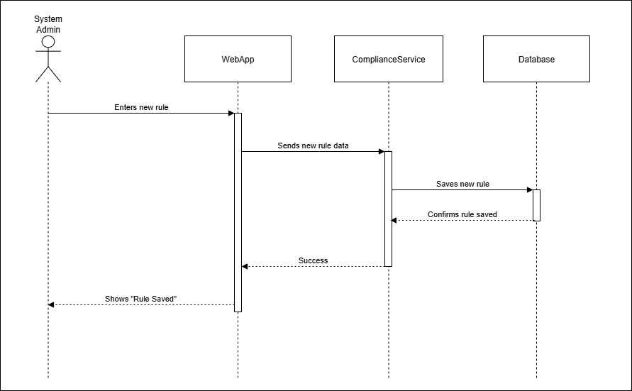

**9.4.12 System Monitoring & Maintenance**

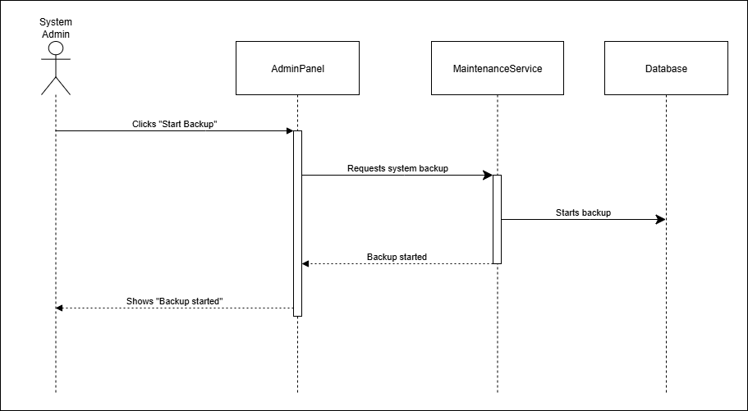

**9.5 Class Diagram**

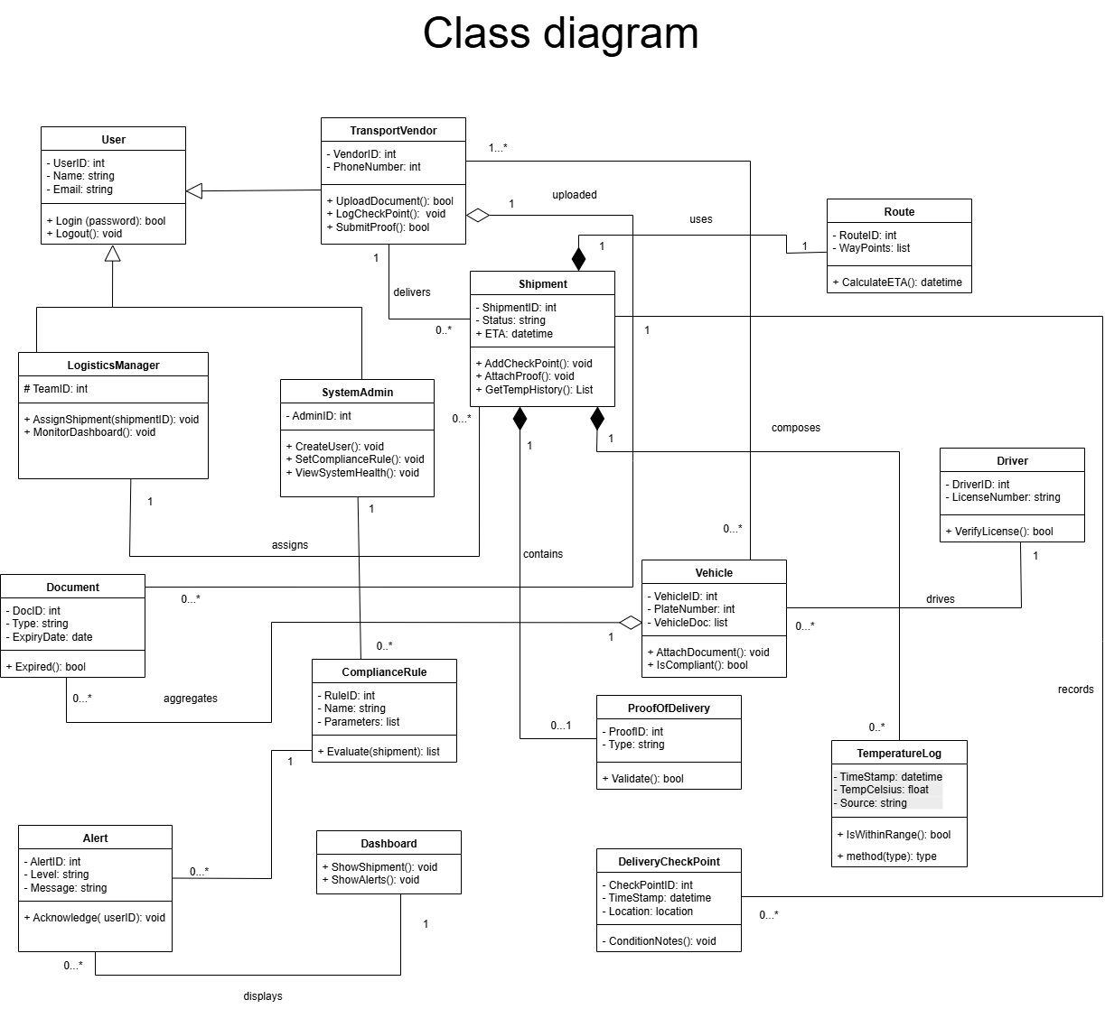

**9.6 ER Diagram**

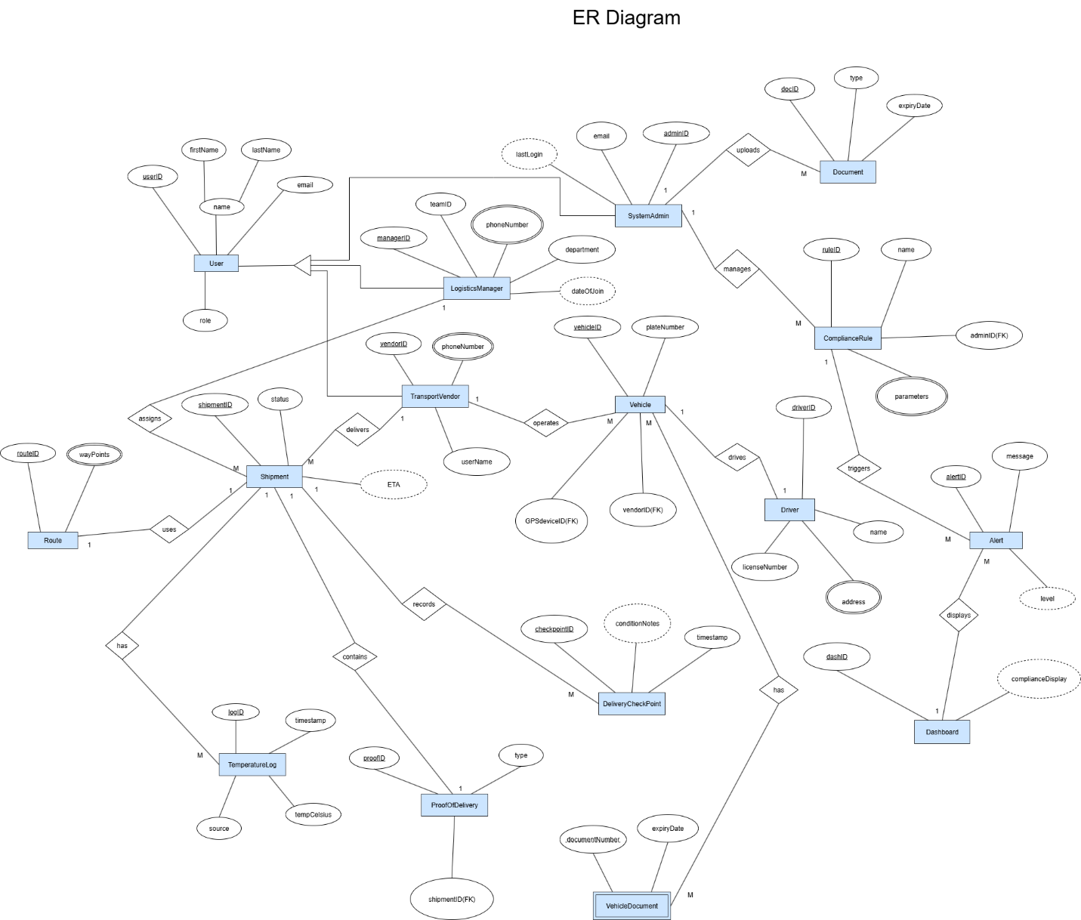

**10. Prototype**

**URL-** [https://effortless-fudge-31781e.netlify.app/#](https://effortless-fudge-31781e.netlify.app/)

**Core Technologies**

* **HTML (HyperText Markup Language):** This is the foundation of the application, used to structure all the content you see on the screen; like the headers, forms, buttons, and cards.
* **JavaScript (JS):** This is the "brain" of the project. It handles all the logic and interactivity, including:
  + Switching between the landing, login, and dashboard pages.
  + Handling form submissions (like creating a new shipment or resetting a password).
  + Saving and retrieving data from the browser's localStorage to simulate a database.
  + Dynamically generating the content on the dashboards, such as the lists of shipments and documents.
* **Tailwind CSS:** This is a modern CSS framework used for all the styling. Instead of writing separate CSS files, it uses utility classes directly in the HTML (e.g., bg-slate-800, font-bold) to control the layout, colors, spacing, and overall visual design. This is what gives the application its clean, minimalistic look.

**Additional Libraries**

* **Chart.js:** This is a popular JavaScript library specifically used to create the interactive **Cold Chain Compliance** line chart on the manager's dashboard.
* **chartjs-plugin-annotation:** This is a plugin for Chart.js that was used to add the shaded "Safe Range" box on the temperature chart, making it easy to see compliance deviations.

**11. References**

* 1. Solving Bangladesh's Cold Chain Logistics Problem: Transmove's Mission to Build a Common Ecosystem for Perishable Goods

<https://www.linkedin.com/pulse/solving-bangladeshs-cold-chain-logistics-problem-mission-akib-mostafa-9rbic>

* 1. Protecting the Quality of Pharmaceuticals in Bangladesh

<https://publications.jsi.com/JSIInternet/Inc/Common/_download_pub.cfm?id=26025&lid=3>

* 1. The rise and impact of Bangladesh's pharmaceutical industry

[https://www.dhl.com/discover/en-bd/e-commerce-advice/e-commerce-sector-guides/rise-impact-outlook-bangladesh-](https://www.dhl.com/discover/en-bd/e-commerce-advice/e-commerce-sector-guides/rise-impact-outlook-bangladesh-pharmaceutical-industry) [pharmaceutical-industry](https://www.dhl.com/discover/en-bd/e-commerce-advice/e-commerce-sector-guides/rise-impact-outlook-bangladesh-pharmaceutical-industry)

* 1. Transportation & Logistic Law in Bangladesh - Jural Acuity

<https://juralacuity.com/transportation-and-logistic-law-in-bangladesh/>

* 1. Temperature Control | FedEx

<https://www.fedex.com/en-us/shipping/temperature-control.html>

* 1. Bangladesh sees significant growth in internet and mobile access - SAMENA Daily News

<https://www.samenacouncil.org/samena_daily_news?news=103792>

* 1. The Agile Software Development Life Cycle | Wrike Agile Guide

<https://www.wrike.com/agile-guide/agile-development-life-cycle/>

* 1. Pathao Courier - Reliable Delivery of Your Product

<https://pathao.com/courier/>

* 1. Paperfly – Strongest Delivery Network

<https://paperfly.com.bd/>

* 1. REDX: Going the distance for Smart Bangladesh | The Daily Star [https://www.thedailystar.net/supplements/smart-bangladesh-inclusive-tomorrow/news/redx-going-the-distance-smart-](https://www.thedailystar.net/supplements/smart-bangladesh-inclusive-tomorrow/news/redx-going-the-distance-smart-bangladesh-3158486) [bangladesh-3158486](https://www.thedailystar.net/supplements/smart-bangladesh-inclusive-tomorrow/news/redx-going-the-distance-smart-bangladesh-3158486)